Session 3
- Using recordings please do a Body scan one day and Movement the next (or a combination each day).
- Anchoring pause – have a go at doing this regularly 2-3 times a day
- Unpleasant events (or annoying things) diary – nothing big, notice your reactions to life’s little annoyances – the crappy things!
- Activity: watch a kettle boil - once a day pay attention to boiling a kettle- from filling it – notice sensations, weight, sounds, the movements you make; then as it comes to the boil notice where your mind wanders, sense of impatience...
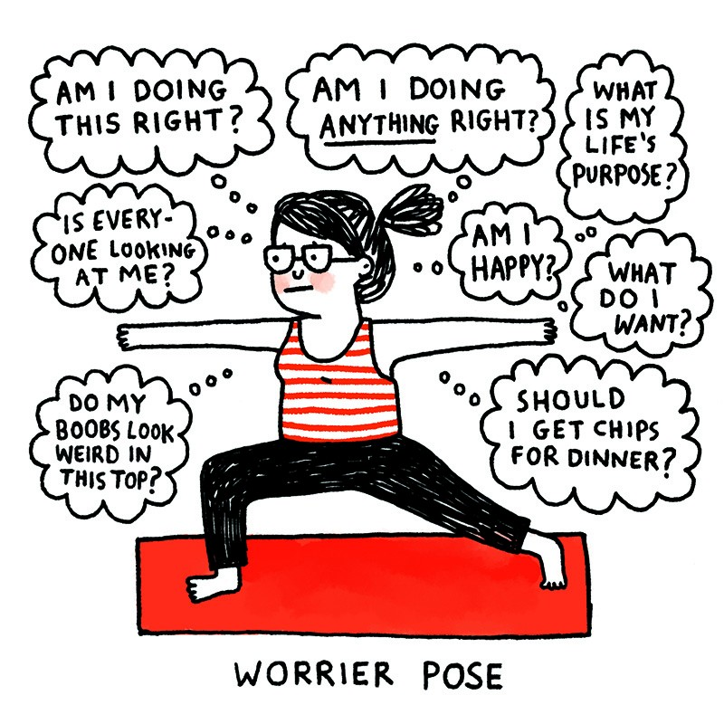

Practising with tracks.
The suggestion is that one day you do a body scan and the other you do some movement, or you could do a bit of both each day.
Here are some movement tracks you can use. It is good to listen to some of these as the attitude and approach is more important than the movements you do! We have a number of choices for you. Make your own decision as to which (if any) of the movements you do. Listen to what your body tells you. Do get in touch if you have a problem.
You may also choose to just do parts of the movement track and then do breath awareness for the rest of the time, perhaps imagining you are doing the movements.
These practices provide an opportunity to tune into sensations in the body in movement, as opposed to in stillness.
Mindful movement suggestions: Attitude and approach are MORE important than making these shapes.
Pete Gladwell is a physiotherapist in pain and fatigue management and is one of the mindfulness group facilitators. He has made this video to guide you with some mindful movement: https://www.youtube.com/watch?v=3NkzBTb0Puc&feature=youtu.be
The video will guide you through the movements shown below, but don’t get put off by the bendy looking character in the pictures: mindful movement is a different approach.
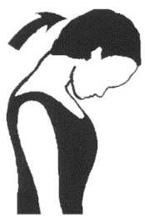 | 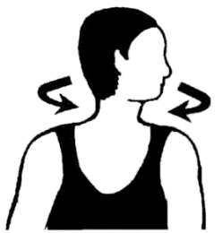 | 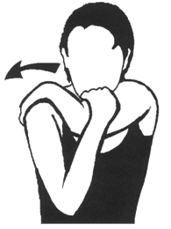
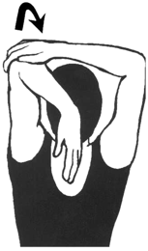 | 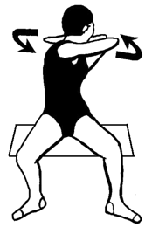 | 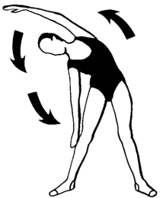
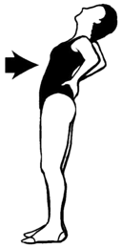 | 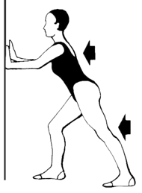 | 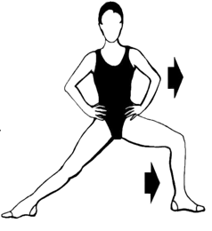

“Standard” mindfulness course movement practice -Do listen to this and make sure you’re OK with it before going for it!
https://soundcloud.com/mindful-health/sets/mindful-yoga-with-taravajara
Fiona has made a lying sequence that is a bit less strenuous:
https://soundcloud.com/fiona-mckechnie108681984/sets/gentle-mindful-movement/s-WlmUv3bYfBQ
Mindful walking can also be an option
https://www.bangor.ac.uk/mindfulness/audio/cd1/04Track04.mp3

The three step anchoring pause (based on breathing space)
3 minute pause with anchor
https://soundcloud.com/fiona-mckechnie108681984/3-minute-pause/s-T9yMnZ8Cq2d
- Awareness
  - Consciously stop, upright posture, drop shoulders
  - "What is my experience right now? .... in thoughts.... in feelings.... and in bodily sensations"
  - Acknowledge and register your experience, even if it is unwanted.
  - Allow the body to move and find an upright, open posture.
  - Notice an aspect of your experience that is soothing, it could be the rise and fall of your breath, contact with the chair, floor etc, warmth in your hands, or the sounds around you
- Gathering
  - Gently gather your attention on the soothing spot as though it were an anchor
  - Whenever your attention wanders, notice then and gently return to the anchor
  - Use the anchor to bring you into the present and to help you tune into a state of awareness and stillness.
  - Notice that the more you notice you wander gives more opportunities to return and therefore the more you can anchor. Ebbing and flowing attention can be a gift.

- Expanding
  - Expand the field of your awareness around your breathing so that it includes a sense of the body as a whole, your posture and facial expression.
Go into your next activity with this awareness
Practice doing this regularly throughout your day
Can help to imagine it in the shape an hourglass:
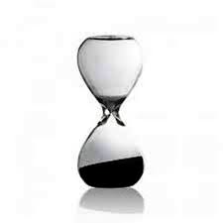
1. Awareness
3. Expanding
2. Gathering

Overall reflections on using a regular breathing space?

When will you do the anchoring pause?
It can be helpful to do it regularly and link it to activities you do any way, e.g. around a meal, when arriving home or at work. Because automatic pilot is so strong, it’s good to decide in advance when you will do it. This table may help you.
Times to do the regular pause
E.g. With morning coffee; when I arrive at work; before I cook tea
Times and note if you did it | Reflection

Reflections

Reflections after the session

Experience of following the guided practice at home- bodyscans and movement (e.g. which practice, how long, what did you notice)

Thoughts about mindful activity

Anything else (e.g. pleasant/unpleasant events)

UNPLEASANT EVENTS: Be aware of an unpleasant event at the time it is happening. Use these questions to focus your awareness on the details of the experience as it is happening. Write it down later
What was the experience? | Were you aware of the feelings while the event was happening? | How did your body feel, in detail, during this experience? | What moods and thoughts accompanied this event? | Behaviour or reaction
e.g. someone at work asks me to do another job | Yes | Tightness in my neck and shoulders, whole body sagging | Angry, helpless. How can I do this when I feel so tired? They will think I’m lazy if I say no. | Worry, stayed at work an extra 2 hours. Felt exhausted

