*Safe and Sustainable Waste*

*Management Policy*

Division: *Trust-Wide*

Document No:HS29

| **Specific staff groups to whom this policy directly applies** | **Likely frequency of use** | **Other staff who may need to be familiar with policy** |
| --- | --- | --- |
| All staff | Daily | Contractors, other organisations based on site. |

|  |  |  |
| --- | --- | --- |
| **Main Author(s):** | | Megan Murphy, Sustainability Manager |
| **Consultation:** | | Waste Services, Health and Safety, Infection Prevention and Control, IM&T, Facilities Management: Operational Services, Estates Maintenance, Sustainable Development Unit, Pharmacy, Pathology, Clinical Equipment Services, Bouygues, Clinical Governance, Waste Compliance Group |
| **Approval Authority (Committee/ Group/ Lead Clinician):** | | Health and Safety Committee |
| **Executive Lead (Trust-Wide only):** | | Glyn Howells |
| **Date of Approval:** | | 23rd March 2023 |
| **Next Review Due:** | | 23rd March 2026 |
| **Version:** | | Version 5.5 |
| **KEYWORDS:** | | Waste, segregation, domestic, confidential, dry mixed recycling, clinical, infectious, contaminated, offensive, pharmaceutical, anatomical, sharps, radioactive, gypsum, electrical waste, WEEE, hazardous, documentation, procedures, Net Zero Carbon, Zero Waste. |
| **Summary of changes since the previous version** | Removed some text and placed into a procedure. Included reference to the Trust’s Net Zero Carbon by 2030 goal, zero waste and circular economy. Made minor changes to roles and responsibilities. Included more detail on cytotoxic and cytostatic waste, pharmaceutical waste and sharps waste. Inclusion of waste classification system. Addition of reusable sharps containers and prohibiting the expulsion of waste pharmaceuticals directly into bins unless they are controlled drugs. | |

# **Executive summary**

* 1. This Policy is to enable the Trust to fulfil its compliance obligations with regards to the production, handling, storage, transportation and disposal of its waste to ensure no harm is inflicted on the organization, people and the natural environment. This policy seeks to prevent prosecution under waste legislation.
  2. This policy will enable the Trust to reduce its waste and reuse as much as is practically possible to reduce carbon emissions associated with waste activity in line with its net zero carbon goal and the Healthier Together ICS Green Plan.
  3. This policy will also ensure the correct segregation of waste to minimise financial costs associated with waste management and to prevent pollution of the natural environment.
* Effective waste management is essential for achieving net zero carbon by 2030, preventing pollution, preventing injuries, being legally compliant and reducing costs.
* Waste management is a line management responsibility with Executive Directors, Clinical Directors, General Managers, and Ward and Department Managers all being accountable for waste management in their own area of responsibility.
* The waste hierarchy and principles of a circular economy must be considered in all waste management and procurement decisions.
* Any waste related duty or activity must be accompanied by a Risk Assessment and all accidents and incidents must be reported through DATIX.
* Waste is segregated by a colour coding system which is reflected in the colour of lids, labels and waste sacks.
* Waste is segregated depending on if it is clinical, infectious, sharp, liquid or hazardous.

Contents

**1.** **Executive summary** 2

**2.** **Purpose of the policy** 6

**3.** **Scope of the Policy** 6

**4.** **Definition of terms** 7

**5.** **Roles and responsibilities** 8

5.1 Responsibilities of the Chief Executive 8

5.2 Responsibilities of the Director of Operational Estates and Facilities 8

5.3 Responsibilities of the Sustainable Development Unit 9

5.4 Responsibilities of Waste Services Manager 9

5.5 Responsibilities of Procurement Managers 10

5.5 Responsibilities of the Estates Maintenance Service (EMS) and PFI partner 10

5.6 Responsibilities of Capital Projects 11

5.7 Responsibilities of Waste Management Services 11

5.8 Responsibilities of Domestics Facilities Management Service 12

5.9 Responsibilities of Managers 12

5.10 Responsibilities of Employees 13

5.11 Responsibilities of Contractors 14

5.12 Responsibilities of other organisations based on site 14

5.13 Responsibilities of employees that appoint contractors 14

6. Procedures 15

6.1 Circular Economy 15

6.2 The Waste Hierarchy 15

6.1.1 Prevention 16

6.1.2 Correctly Segregate 16

6.1.3 Reuse 16

6.1.4 Recycle 17

6.1.5 Recover 17

6.1.6 Disposal 17

6.1.7 Landfill 17

6.2 Health and Safety 17

6.2.1 Spillages 17

6.2.2 Risk Assessments 18

6.2.3 Accidents and Incidents 18

6.2.4 Protective Clothing and Immunisations 18

6.3 Waste Classification and Handling 18

6.3.1 Colour Code System 18

6.3.2 BioTrack Tagging System 19

6.3.3 Handling Waste Sacks 19

6.4 Domestic and Recyclable Waste 19

6.4.1 Types of Domestic and Recyclable Waste 19

6.4.2 Departmental Waste Bins 24

6.4.3 Confidential Waste 24

6.5 Hazardous and WEEE waste 24

6.5.1 Types of Hazardous Wastes 24

6.5.2 Types of WEEE Waste 26

6.5.3 Hazardous Battery Waste 27

6.5.4 Radioactive Waste 27

6.5.5 Liquid waste 27

6.6 Clinical Waste 28

6.6.1 Types of Clinical Waste 28

6.6.2 Sharps 32

6.6.3 Pharmaceutical Waste 32

6.6.4 Pathology Waste and Microbial Samples and Cultures 33

6.6.5 Creutzfeldt–Jakob Disease (CJD) 33

6.6.6 Suspected CJD Cases 33

6.6.7 Category A Pathogen Waste 34

6.7 Moving Waste 34

6.7.1 Operation of Waste Handling Equipment 34

6.7.2 Waste Storage 34

6.7.3 Cleaning of Storage Areas 35

6.7.4 Transport of Waste Onsite 35

6.7.5 Transport of Waste Offsite 36

6.7.6 Final Disposal of Waste 36

6.7.7 Site Registration, Legal Paperwork, Records and Exemptions 36

6.7.7.1 Waste Transfer Notes 37

6.7.7.2 Hazardous Waste Consignment Notes 37

6.7.7.3 Completion of Waste Documentation 37

6.7.7.4 Environmental Permitting and Waste Exemptions 38

6.7.7.5 Trust Waste Carriers License 38

7. Monitoring Effectiveness 38

7.1 Training 38

7.2 Audit Objectives 38

7.3 Audit Procedures 38

7.4 Reporting 39

7.5 Procedure Non-Compliance 40

7.6 Review 40

7.7 Monitoring Effectiveness Summary 41

8. Associated Policies 45

9. References 45

9.1 Guidance 45

9.2 Legislation 46

10. Appendices 48

Appendix A – Five R’s of sustainable procurement 48

Appendix B – Circular Economy Principles 48

Appendix C – Acceptable Waste Receptacles 49

Appendix D – BioTrack Labels 49

Appendix E – Relationships between waste types 50

Appendix F – Waste segregation and classification 51

Appendix G – Waste Transfer Note 52

Appendix H – Hazardous Waste Consignment Note 53

Appendix I – Duty of Care Checklist 54

10. Appendices………………………………………………………………………………………………..44

**The following headings are for Trust-Wide Clinical/ Corporate Policies**

# **Purpose of the policy**

* 1. The purpose of this policy is to enable North Bristol NHS Trust to fulfil its compliance obligations, to protect the environment and its staff, patients, visitors, contractors and the wider community from exposure to the waste produced.
  2. It is important that we manage our waste effectively due to:
     + Net Zero Carbon by 2030 Goal: the treatment of our waste makes up 1% of NBT’s carbon footprint, equivalent to burning 300 tonnes of coal each year. Reducing our waste and managing it more sustainably is crucial to achieving our Net Zero Carbon by 2030 goal.
     + Pollution and Odour: poor storage, management and transportation of waste can lead to odour and the pollution of air, local habitats, water bodies and soil.
     + Health and Safety: poor waste segregation and practice can lead to needle stick injuries and slip, trip and fall hazards.
     + Legal requirements: the Trust has a legal duty of care to ensure its waste causes no harm to people and the environment.
     + Cost: poor waste segregation can lead to financial penalties. In 2021-22 NBT spent over £1 million in waste management costs. If we segregated our waste better and recycled more, we could reinvest these costs in improving patient care.
  3. This policy seeks to prevent prosecution under waste legislation, ensure the correct segregation of waste, reduce the amount of waste produced and prevent harm being inflicted on the organization, people and the environment.
  4. This policy will enable the implementation of the waste hierarchy during the production and disposal of waste to ensure all reasonable steps are taken to prevent and reduce waste, prepare waste for reuse, recycle and recover energy from non-recyclable waste.

# **Scope of the Policy**

* 1. The Trust is one of the largest healthcare providers in the region, and as such produces a significant volume of waste.
  2. This is a trust-wide policy which applies to the production, handling, storage, transportation and disposal of healthcare waste produced by North Bristol NHS Trust premises, staff, patients, visitors, contractors and the public.
  3. The policy applies to all personnel (including temporary and agency personnel, volunteers, students and those on work experience) in both clinical and non-clinical settings. All members of North Bristol NHS Trust staff that generate waste are legally obligated to ensure the waste is correctly segregated, handled, classified and disposed of.
  4. Any organisations based on North Bristol NHS Trust premises whose waste is managed and disposed of by the Trust will be required to follow the procedures outlined in this document.

# **Definition of terms**

|  |  |
| --- | --- |
| Term | Definition |
| Waste | Any substance or object which the holder discards or intends or is required to discard. |
| Clinical Waste | Waste containing viable micro-organisms or their toxins which are known or reliably believed to cause disease in humans or other living organisms. Waste which contains or is contaminated with a medicine that contains a biologically active pharmaceutical agent. Sharp waste, or a body fluid or other biological material (including human and animal tissue) containing or contaminated with a dangerous substance as defined by EC No 1271/2008 (The Classification, Labelling, and Packaging Regulation). |
| Net Zero Carbon | An organisation, activity or building which has reduced all carbon emissions associated with its direct and indirect activity by 90-95% against an established baseline with the remaining carbon emissions offset through accredited carbon offsetting schemes. |
| Sustainability | The integration of environmental health, social equity and economic vitality in order to create thriving, healthy, diverse and resilient communities for this generation and generations to come. |
| WEEE | Waste Electrical and Electronic Equipment is any equipment that requires an electrical current to operate which includes most products that have a plug, require a battery and contain a chip. |
| SOP | Standard Operating Procedure |
| SSoW | Safe Systems of Work |
| Circular Economy | A framework that aims to change the way things are designed to eliminate waste and pollution, circulate products and materials at their highest value and regenerate nature. It transforms waste into a commodity where value of materials are retained in the supply chain / market. |
| Zero Waste | The Trust produces no waste – all products and materials are reused, reprocessed and repaired. |
| Controlled Drugs | Drugs that are subject to special legislative controls, as they are potentially harmful. Controlled Drugs are classified into five schedules which dictate the level of control required for each medicine. Please refer to The Misuse of Drugs Regulations for medicines that are classified as controlled drugs. |

# **Roles and responsibilities**

Waste management is a line management responsibility with Executive Directors, Clinical Directors, General Managers, and Ward and Department Managers all being accountable for waste management in their own area of responsibility.

5.1 Responsibilities of the Chief Executive

The Chief Executive of the Trust has ultimate management responsibility for the safe management of waste within the Trust.

The responsibilities of the Chief Executive include:

* Ensure the safe and compliant management of waste.
* Direct and support the establishment and management of on-site waste infrastructure and services.
* Ensuring the Trust has a Waste Management Policy in place to meet legislative and policy requirements.
* Ensuring that the Trust Waste Management Policy is implemented monitored and regularly reviewed.
* Ensuring that appropriate investment in the management and reduction of waste and waste carbon emissions is properly accounted for in the Trust’s business plans.

5.2 Responsibilities of the Director of Operational Estates and Facilities

The responsibilities of the Director of Operational Estates and Facilities include:

* Ensuring that the Trust has qualified and competent staff responsible for the safe management of waste.
* Ensuring that the Trust complies with current legislation and guidance relating to waste compliance.
* Ensuring that appropriate resources are made available for the safe management of waste and associated staff training.
* Ensuring the Trust reduces waste and associated carbon emissions in line with the net zero carbon goal and the Healthier Together ICS Green Plan.

5.3 Responsibilities of the Sustainable Development Unit

The responsibilities of the Sustainable Development Unit include:

* Assist with the update and review of the Trust Policy on Waste Management and the Safe Handling of Waste.
* Provide specialist advice to the Waste Services Manager and Trust employees.
* Investigate and review reported breaches in legislation.
* Liaise with the Environment Agency (on breaches in legislation and environmental incidents), waste disposal contractors, the Estate Maintenance Service, Dangerous Goods Safety Advisors and any other parties necessary for the safe and legal management of waste.
* To periodically monitor and audit the retention and filing of Waste Transfer and Consignment notes to fulfil duty of care compliance obligations.
* To monitor waste best practice and initiatives and make recommendations for trial/adoption at NBT.
* To collect, monitor, analyse and report waste data as and when required in the Trust Annual Report, ICS Green Plan report and ERIC.
* To develop and deliver a communication and engagement programme to encourage best practice, improve waste behaviours and awareness.

5.4 Responsibilities of Waste Services Manager

The responsibilities of the Waste Services Manager include:

* To manage the day-to-day operational waste activities for the Trust, including all budgetary decisions and the collation, monitoring and recording of waste data.
* To ensure the timely collection and accuracy of waste data.
* Identifying and sourcing required resource and infrastructure to enable waste segregation best practice.
* Update and review Trust waste procedures and the Trust Policy on Waste Management.
* Implement and manage waste contracts – monthly review meetings, monitoring of KPIs, conflict resolution for Domestic Waste, Confidential Waste and Clinical Waste contracts.
* Liaise with waste contractors to flag and resolve issues related to waste segregation, collection and compliance.
* Arrangement of waste collections outside of dedicated contracts such as WEEE, hazardous materials (chemicals, batteries, aerosols etc.).
* Management of waste equipment contracts (e.g. compactors, balers, tippers).
* Management and retention of waste documentation (i.e. waste transfer notes, consignment notes and quarterly returns) for all transfers and disposals of waste.
* Representing the Trust at national and regional waste fora.
* Identifying and attending conferences and training courses.
* Arranging the servicing of waste equipment and responding to break-downs.
* Preparation of Waste Management Business Continuity Plans.
* Preparation of all capital bids relating to operational waste management (jointly with SDU).
* Organising meetings of the Trust-wide Waste Compliance Group.
* Attending and contributing to the ICS Sustainable Waste Workstream and Green Plan Implementation Group.
* Investigating and reviewing reported waste handling incidents and accidents.
* Developing and delivering Trust-wide waste training and bespoke departmental training.
* To audit Trust-wide waste segregation, storage provision, packaging and readiness for transportation and general compliance with this policy.
* Conducting Duty of Care and pre-acceptance audits and co-ordinating visits from the Trust’s Dangerous Goods Safety Advisor.
* Reporting audit findings through key governance groups and to Facilities Management and the Sustainable Development Unit.
* Distribute communication and engagement materials and resources provided by the Sustainable Development Unit.
* Monitor the Waste Services email and respond to staff queries.

5.5 Responsibilities of Procurement Managers

Procurement Managers must refer to the Procurement Strategy and the Ethical Procurement Policy for guidance on reducing waste through procurement processes. The responsibilities of procurement managers include:

* Applying the waste hierarchy and the five R’s (Appendix A) in all procurement processes i.e., procurement strategy, tender specification, tender evaluation, contract award and contract management.
* Deliver the safe and sustainable selection of health products and waste services to reduce waste.
* Implement sustainable procurement initiatives to reduce waste.
* Ensure all procurement staff are trained and competent in sustainable procurement practices and delivery.
* Engage with clinical and non-clinical staff through procurement processes to minimise waste of procured products and services.
* Engage with the market to promote NBT’s net zero carbon and zero waste goals and increase the availability of zero waste innovations and technology in the market.
* Ensure the collection and monitoring of appropriate data and KPIs that demonstrate progress of implementing the waste hierarchy and reducing waste carbon emissions through procurement processes.

5.5 Responsibilities of the Estates Maintenance Service (EMS) and PFI partner

For the management of Estates Maintenance waste staff must refer to the Managing Waste Environmental Guidance Note EGN12. The responsibilities of the Estate Maintenance Service include:

* Ensuring all Estate Maintenance staff meet the requirements of this Policy.
* Ensuring Estate Maintenance projects apply the waste management hierarchy (see Definition of Terms) within the design and planning process.
* Dispose of waste produced during project delivery via the most sustainable method in the waste hierarchy as is practically possible.
* Ensuring all contract tenders include circular waste management, social value and carbon emission specification relative to the project.
* Ensuring all contracts include key performance indicators on circular waste management, social value and carbon emissions within the contract management.
* Responsibilities outlined in section 5.13 for the Appointment of Contractors.
* Estates Maintenance are responsible for the day-to-day removal and safe and sustainable disposal of the following waste:
  + Asbestos
  + Fluorescent tubes/CFLs/Light bulbs
  + Automotive lead acid batteries
  + Building demolition material
  + Industrial chemicals
  + Herbicides and pesticides
  + Paints
  + Oily waste (contaminated water, rags, etc.)
  + Waste Oil
  + Other (e.g. pipework, carpets, generated through their maintenance activities etc.)

5.6 Responsibilities of Capital Projects

For the management of Capital Projects waste staff must refer to the Managing Waste Environmental Guidance Note EGN12. The responsibilities of the Capital Projects team include:

* Ensuring all capital projects apply the waste management hierarchy (see Definition of Terms) within the design and planning process.
* Dispose of waste produced during project delivery via the most sustainable method in the waste hierarchy as is practically possible.
* Ensuring all contract tenders include circular waste management, social value and net zero carbon specification relative to the project.
* Ensuring all contracts include key performance indicators on circular waste management, social value and carbon emissions within the contract management.
* Responsibilities outlined in section 5.13 for the Appointment of Contractors.

5.7 Responsibilities of Waste Management Services

The responsibilities of the Waste Management Services Team Leaders include:

* Ensuring adequate and appropriate waste collection and transport on site.
* Providing the appropriate and timely waste collection for external bins.
* Providing appropriate and timely ad hoc collection services for waste streams such as CJD waste, Highly Infectious waste, WEEE, batteries, aerosols and mercury-containing waste (e.g. thermometers).
* Ensuring collection of hazardous waste streams (i.e. sharps, cytotoxic, cytostatic, anatomical) are segregated correctly, and labelled with the correct List of Waste (LoW)/European Waste Catalogue (EWC) code for transportation.
* Ensuring the correct LoW/EWC label is attached to every collection bin on site.
* Monitoring the activities of the waste collection contractors and assisting with bin audits.
* Ensuring data for the completion of Waste Transfer and Consignment Notes for all clinical waste collections is adequately generated through bin weighing.
* Checking all bin deliveries and returning faulty bins.
* Conducting weekly bin and waste hold audits.
* Checking all bins for correct segregation prior to consignment/sending off-site.
* Ensuring bulk bins are locked after use.
* Ensuring that Waste Transfer Notes and Hazardous Consignment Notes are completed (may be completed by contractors) and retained as per the regulation requirements.
* Ensuring all staff receive appropriate training on the different categories, handling, storage and transport of waste.
* Ensuring waste compound areas are kept locked at all times and are regularly cleaned.
* Reporting to the Waste Services Manager and Sustainable Development Unit any areas where poor waste management practices are occurring and report incidents via DATIX.
* Ensuring safe systems of work are completed and complied with including the wearing of PPE.

5.8 Responsibilities of Domestics Facilities Management Service

The responsibilities of the Domestics Service Team Leaders include:

* Ensuring all internal waste bins are labelled correctly to reflect the waste type and the correct colour sack is used to reflect the bin label.
* Ensuring adequate supplies to wards/areas of appropriate coloured sacks (and coded pull-ties for clinical sacks) for all waste streams.
* Ensuring adequate and timely collection of waste from all areas.
* Ensuring all staff correctly close (swan neck) and tag clinical waste bags.
* Ensuring staff are trained in the different categories, correct handling, and storage of waste.
* Ensuring waste storage areas are cleaned on a regular basis.
* Ensuring safe systems of work are completed and complied with including the wearing of PPE.
* Reporting to the Waste Services Manager and Sustainable Development Unit any areas where poor waste management practices are occurring and report incidents via Datix form.

5.9 Responsibilities of Managers

Managers (those with budgetary and/or staff management responsibilities) are required to:

* Ensure adequate arrangements are in place for this policy to be fully implemented at ward and department level.
* Identify all significant hazards arising from waste management, evaluate the risks and introduce controls to reduce the risk.
* Ensure that safe systems of work for waste handling and disposal are used within their area of responsibility.
* Report and investigate any incident or near miss via Datix which occurs within their area of responsibility.
* Co-operate during internal and external waste audits.
* Ensure waste bins are fit for purpose and purchase new ones when required. This is the responsibility of individual areas and *not* domestic services.
* Ensure a sufficient number of bins are located close to waste generation to enable correct waste segregation and redistribute bins where there are too many or too few for one type of waste stream.
* Ensure staff are aware of their waste management responsibilities and legal Duty of Care.
* Ensure staff are trained in the correct segregation, handling and disposal of waste and have completed their mandatory online waste training.
* Identify when bespoke waste training is required and request from the Waste Services Manager and Sustainable Development Unit.
* Ensure appropriate PPE and waste signage is available where required (example anti needle-stick gloves and orange magnetic labels).
* Ensure resources are available for waste disposal beyond what that department is typically expected to produce (e.g. disposal costs associated with clear-outs, office moves and building or engineering works other than maintenance).
* Ensure that NBT’s re-use portal, Warp-It, is used to check for items of furniture/equipment that are already available within the Trust before ordering new furniture/equipment to reduce waste disposal and procurement costs and carbon emissions.
* Prior to the procurement of any new products or services, engage with the supplier and/or specify within the tender that waste associated with the procurement must be eliminated or reduced where possible, taking into consideration:
  + the end disposal costs of any products,
  + waste generated during product lifetime (e.g. consumables),
  + any hazardous waste which may be generated (e.g. batteries, time-expired alcohol gel),
  + the packaging of the product or of any consumables used as part of its use,
  + the reusability or recyclability of the product at the end of its life.
* Responsibilities outlined in section 5.13 for the Appointment of Contractors.

5.10 Responsibilities of Employees

For the management of waste produced by hospital staff, employees must refer to the Managing Waste Environmental Guidance Note EGN12. The responsibilities of employees include:

* Identifying any substance or material they are disposing of and ensuring it is segregated into the correct colour coded sack or container for disposal in accordance with this policy.
* Recognising they have a legal Duty of Care with regard to correctly segregated waste (under the Environmental Protection (Duty of Care) Regulations, 1991). This means taking reasonable measures to ensure that their waste is stored in a safe and secure manner and thereby prevents harm to Trust employees, patients, visitors, wider community and the environment.
* Ensuring only authorised personnel removes the waste from their area.
* Complying with the requirements of this policy.
* Attending all appropriate waste management training as determined by the responsibilities and job function of the individual (as detailed in individual training passports).
* Preventing the generation of waste within their control by repairing, remanufacturing and reusing waste wherever possible and disposing of waste via the most sustainable method within the waste hierarchy as is practically possible.
* Ensuring any staff members working on non-North Bristol NHS Trust sites are responsible for familiarising themselves with the local waste procedures.
* Responsibilities outlined in section 5.13 for the Appointment of Contractors.

5.11 Responsibilities of Contractors

The responsibilities of contractors include:

* Ensuring they are legally compliant and hold the correct waste management licences, permits or exemptions and provide these to the Trust on request.
* Ensuring any breach in environmental legislation resulting in prosecution is reported to the Trust.
* Ensuring they follow the Trust Waste Policy when operating onsite.
* Not using Trust waste containers for the disposal of their waste unless this has been specifically agreed with the Waste Services Manager.
* Preventing the generation of waste within their control by repairing, remanufacturing and reusing waste wherever possible and disposing of waste via the most sustainable method within the waste hierarchy as is practically possible.
* Reduce carbon emissions associated with the waste they generate.
* Identifying risks to the natural environment due to the waste generation within their control and implementing control measures to mitigate these risks.
* Ensuring contingency plans are in place for the safe and sustainable management of waste.

5.12 Responsibilities of other organisations based on site

The responsibilities of other organisations based on site include:

* Ensuring they are legally compliant and hold the correct waste management licences, permits or exemptions (if applicable).
* Ensuring they follow the Trust Waste Policy when operating onsite.
* Ensuring any contractors working on their behalf are legally compliant and have not been prosecuted for waste offences in the last three years.
* Responsibilities outlined in section 5.13 for the Appointment of Contractors.

5.13 Responsibilities of employees that appoint contractors

Employees that appoint contractors for any type of work, service or project that will result in the generation of waste must refer to the Managing Contractors Waste Environmental Guidance Note (EGN2). Trust employees must also ensure that the following requirements are met (seek advice from the Sustainable Development Unit if required):

* Ensure all contractors working onsite do so in line with Trust Policy (Waste Policy, Sustainable Development Policy, Control of Contractors Policy, etc.) to reduce their impact on the environment.
* Organise and deliver a contractor initiation meeting to make contractors aware of their legal obligations, Trust Policy and Plans.
* Ensure that checks are made to determine whether the contractor has been prosecuted (or served a notice) for breaches in environmental legislation in the last three years (and seek guidance from the Sustainable Development Unit if this is the case).
* Conduct Duty of Care audits and Pre-Qualification checks on service providers and suppliers prior to the transferral and/or disposal of waste on behalf of the Trust, ensuring that all waste contractors working on behalf of the Trust are legally compliant and hold the correct waste carriers licences, permits or exemptions.
* Ensure all contractors provide fully and accurately completed waste documentation (waste transfer notes and hazardous waste consignment notes) for all waste transferred and disposed of on behalf of the Trust.
* Report waste management documentation to the Waste Services Manager and Sustainable Development Unit as and when waste is transferred and/or disposed of.
* Ensure all waste documents are stored on file for the appropriate time as per the regulation requirements.
* Ensure contractors have plans to reduce the carbon emissions related to waste generated as a result of the work/service/project over the course of the contract.
* Ensuring contractors have contingency plans in place for the safe and sustainable management of waste.

1. Procedures
   1. Circular Economy

In order to achieve net zero carbon by 2030 and become a zero-waste organisation, the Trust must apply the principles of a circular economy (Appendix B) into the full lifecycle of the procurement of goods and services as per the Trust’s Ethical Procurement Policy. Applying the principles of a circular economy to our procurement and waste management practices is key to delivering the Sustainability Improvement Priority of the Trust Strategy as it allows us to utilise our limited resources for as long as possible.

* 1. The Waste Hierarchy

The waste hierarchy is a framework for managing waste which ranks disposal methods according to their environmental impact, with ‘Prevention’ being the most preferrable option and ‘Landfill’ the least. The hierarchy comes from Article 4 of the EU’s Waste Framework Directive and is still used in the UK as guidance for best practice waste management. The Trust has adopted the waste hierarchy from HTM 07-01 to drive us towards our goal of becoming net zero carbon by 2030 and a zero-waste organisation.

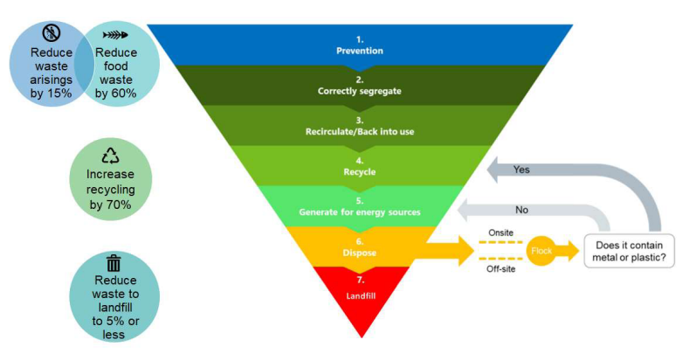

6.1.1 Prevention

Waste is prevented by limiting the demand for products and services through refusing new products and services, reducing consumption, rethinking processes, redesigning products and services and repairing. Products and services procured by the Trust are designed to produce no waste during their use and at the end of their lives. The Trust ensures we procure and accept only what we absolutely require and refuse any unnecessary and wasteful products from our suppliers. Tender specifications, market engagement and contracts drive the supply chain to remove waste from their products and services through innovation and technology. Broken furniture, equipment and devices are repaired internally by inhouse experts or externally through contractors and suppliers. Service contracts are procured to ensure equipment is durable and sufficiently maintained.

Trust processes are designed to be circular in nature, ensuring no waste is produced as a result of our activities.

6.1.2 Correctly Segregate

Suitable infrastructure and processes are in place to enable the segregation of waste at the point of generation to maximise the opportunities for reuse, recycling and recovery. The segregation of waste should be conducted in a way that it can be viewed as a valuable commodity and potentially sold for remanufacturing, reprocessing or reuse.

6.1.3 Reuse

Materials and products are sufficiently treated and prepared for reuse. Non-medical devices, equipment and furniture are reused through the Trusts warp it portal, through auctions and the CollectEco service ([wishlist@collecteco.co.uk](mailto:wishlist@collecteco.co.uk)). Medical and IT devices and equipment are returned to suppliers and manufacturers as part of a service contract for reuse. Local reuse schemes and programmes are utilised by the Trust and the Trust itself becomes a reuse hub for patient equipment and devices. Reuse retains the value of our products and establishes a circular loop.

6.1.4 Recycle

The Trust recycles products and materials into a new product through recycling, reprocessing and remanufacturing. The Trust procures products and packaging that are made of recycled and recyclable materials. The Trust identifies local recycling schemes for its products and the Trust itself becomes a recycling hub for patient equipment and devices. Medical and IT devices and equipment are returned to suppliers for remanufacturing and reprocessing into a new product. Recycling, reprocessing and remanufacturing partially retains the value of our procured goods but is not an infinite process and requires energy and resources to generate a new product. Each time material is recycled it becomes a lower quality product.

6.1.5 Recover

Waste is processed and used as a fuel or feedstock in energy generation and the recovery of water, heat, materials and nutrients such as in cement production or anaerobic digestion. These generation and recovery processes can produce greenhouse gases and harmful pollutants which create poor air and water quality locally to these plants. This method of waste disposal destroys the waste and therefore fails to retain the value of our procured goods and makes them impossible to be recycled or reused.

* + 1. Disposal

Waste is disposed of via domestic waste stream and is sorted on or off site by waste services or waste contractors. Items that can be recycled are sorted into a separate recycled waste stream and suitable items that cannot be recycled are sent for energy generation or recovery.

* + 1. Landfill

Waste is disposed of in landfill, abiding by the principles of a linear economy whereby material is not segregated, reused, recycled or used in a recovery process and the value of the material is not retained within the supply chain. The material has escaped the supply chain after one use and cannot be used to create new materials or products.

* 1. Health and Safety

6.2.1 Spillages

Staff must refer to the Spill Response Procedure Environmental Guidance Note EGN3 for guidance on spill response.

* All spillages should be regarded as potentially hazardous and dealt with immediately.
* For the correct handling of spillages related to cytotoxic and cytostatic medicines please refer to Section 20 of the Safe Handling of Cytotoxic Compounds Policy (CG-82).
* When dealing with spillages, appropriate protective clothing must be worn.
* Where required, another member of staff should assist in keeping the spillage area safe, until the area can be barricaded off.
* All waste produced from dealing with any spillage must be packaged and disposed of appropriately.
* All significant spillages must be reported on Datix. Please refer to the Trust’s Incident Reporting Policy (CG01a).
* Bodily fluid spillages which occur within a ward must be dealt with by ward staff.
* Bodily fluid spillages in other internal areas (e.g., corridors) should be dealt with by Patient Support Team - Team Leader.
* In the event of a mercury spillage, please use single-use gloves (of a type that does not allow mercury to pass through), paper towels, a bulb aspirator for the collection of large drops of mercury, a vapour mask and a suitable receptacle fitted with a seal and mercury-absorbent paste.
* Spillages which occur externally (e.g. Within the hospital grounds) should be dealt with by appropriately trained staff within the Estates Department.
* Refer to COSHH assessments and safety data sheets of spilt liquids where applicable.

6.2.2 Risk Assessments

Managers must ensure that Risk Assessments are undertaken by a trained person to identify and assess the risks to staff and others from any waste related duties and activities (including waste handling, collection, storage, movement and disposal). Risk Assessments must be updated when changes are made to any aspect of waste and communicated to all relevant staff.

6.2.3 Accidents and Incidents

All accidents and incidents involving waste items should be recorded and reported on DATIX.

In the event of a sharps injury staff must follow the Needlestick / Contamination Procedure from Section 8.6 of the Sharps Management Policy HS07.

6.2.4 Protective Clothing and Immunisations

All staff should be issued with and wear appropriate protective clothing and equipment, to allow them to complete their waste related duties.

Staff handling clinical and hazardous waste will be offered immunisation which is based on risk assessments undertaken by theirmanagers. For more information staff should speak to their line manager or Occupational Health.

* 1. Waste Classification and Handling

6.3.1 Colour Code System

Healthcare waste is classified by a colour coding system which is outlined in Table 1. The lids and labels of rigid clinical waste containers and waste sacks all comply with this colour coding system to indicate the type of waste that can be disposed of in that bin. More information on the type of receptacles and sacks used for each waste stream can be found in Appendix C.

Table 1

|  |  |  |  |  |  |
| --- | --- | --- | --- | --- | --- |
| **Waste Type** | **Colour** | **Colour** | **Minimum required treatment** | **BioTrack Code** | **Hazardous** |
| Infectious (Category B) |  | Orange | Alternative Treatment | HT | P |
| Infectious Sharps (Category A) |  | Yellow | Incineration | HI | P |
| Infectious (Category A) |  | Yellow | Incineration | HS | P |
| Anatomical |  | Red | Incineration | HA | P |
| Cytotoxic / Cytostatic |  | Purple | HT Incineration | HY | P |
| Pharmaceutical |  | Blue | Incineration | HP |  |
| Offensive |  | Tiger (yellow with black stripes) | Landfill | HL |  |
| Domestic |  | Black |  |  |  |
| Recycling |  | Clear |  |  |  |

6.3.2 BioTrack Tagging System

BioTrack labels ensure the safe and compliant carriage of waste from a producer’s premises to a transfer station or end disposal site. The type of tag required for each clinical waste stream is detailed in Table 1. Examples of each BioTrack label is provided in Appendix D. BioTrack labels contain information on the UN number and EWC code as well as a unique barcode number which can trace the waste back to our site.

Wheeled bins must contain one type of clinical waste at one time. A BioTrack tag must be attached to every wheeled bin containing clinical waste at the point of waste generation or collection by portering staff. Wheeled bins without tags will not be collected by the clinical waste contractor.

6.3.3 Handling Waste Sacks

All staff must refer to the Handling Waste Sacks Procedure for handling clinical and non-clinical soft, sack waste.

* 1. Domestic and Recyclable Waste

6.4.1 Types of Domestic and Recyclable Waste

Domestic and recyclable waste is all waste that is not clinical or hazardous and is typically identifiable as waste generated from an office, home or kitchen environment. Most of this waste is recyclable and the Trust provides clear sacks for this purpose. Non-recyclable domestic waste should be disposed of in black sacks. For further information and guidance on identifying and classifying non-clinical waste, please refer to the Venn diagram and flowchart in Appendices E and F. Posters for each waste stream can be found on the staff intranet page. Please refer to Table 2 for a list of domestic and recyclable waste and their correct disposal methods.

Table 2

|  |  |  |  |
| --- | --- | --- | --- |
| Waste type | Examples | Disposal method | Collected by |
| Dry Mixed Recycling   * Non-confidential and shredded confidential paper * Cardboard * Plastic * Aluminum and tin | * Envelopes * Any colour paper * Newspapers and magazines * Leaflets * Plastic bottles, tubs, pots, trays and film * Medical equipment sterile packaging * Small boxes * Pulp trays * Clean food or drink cartons, tins and cans * Feed bottles * Empty alcohol gel bottles | 1. Empty, rinse and clean food and drink containers 2. Separate plastic and paper sterile packaging before disposal. 3. Scrunch mixed material medical packaging into a ball and if it does not pop back into original shape, it can be recycled. 4. Put waste mixed in clear sack 5. Contaminated recyclables will be sent to landfill/energy recovery | Waste services |
| Cardboard | * Cardboard packaging or boxes larger than a cereal box | 1. Flatten cardboard boxes and packaging 2. Leave beside internal waste bin or put in cage in disposal hold or in designated external wheeled bins. | Waste services |
| Confidential Paper Waste | * Paper waste containing staff or patient details * Paper containing sensitive information about the Trust | 1. Place day-to-day generated confidential paper waste in designated confidential consoles. 2. For periodic clear-outs place confidential paper waste in dedicated paper sacks available via the FM Helpdesk ext 5555. | Confidential waste contractor |
| Confidential Media Waste | * CDs and DVDs * Photographic slides * Carbon fax rolls * X-rays * Floppy discs * Non-paper media | 1. Arrange collection with Waste Services by emailing [WasteServices@nbt.nhs.uk](mailto:WasteServices@nbt.nhs.uk) or calling the FM Helpdesk on ext 5555. | Waste Services |
| IT consumables | * Ink and toner cartridges | 1. Package securely 2. Arrange collection with Waste Services by emailing [WasteServices@nbt.nhs.uk](mailto:WasteServices@nbt.nhs.uk) or calling the FM Helpdesk on ext 5555. | External contractor will be arranged via Waste Services |
| Edible Oil and Fat | * Cooking oil | 1. Catering department | Catering contractor |
| Domestic Glass | * Food and drink glass bottles and jars | 1. Put carefully into designated glass caddy. 2. Broken glass must be placed in a cardboard box that is taped up and labelled ‘BROKEN GLASS’. 3. Large producers of glass should use designated external wheeled bins. | Waste Services |
| Broken Crockery | * Plates, cups and dinner ware | 1. Place carefully into a cardboard box 2. Tape the box up and label ‘BROKEN CROCKERY’. 3. Place box in waste hold for collection | Waste Services |
| Non-Pharmaceutical Aerosols | * Air fresheners * Cleaning products * Deodorants | 1. Put in clear sack 2. Arrange collection with Waste Services by emailing [WasteServices@nbt.nhs.uk](mailto:WasteServices@nbt.nhs.uk) or calling the FM Helpdesk on ext 5555. | Waste services |
| Non-hazardous Batteries | * Nickel-metal hydride (NIMH) batteries * Alkaline batteries * Lithium batteries | 1. Tape over battery terminals 2. Place in plastic container e.g. ice cream tub or clear sack 3. Arrange collection with Waste Services by emailing [WasteServices@nbt.nhs.uk](mailto:WasteServices@nbt.nhs.uk) or calling the FM Helpdesk on ext 5555. | Waste services |
| CDs and DVDs with confidential material |  | 1. Arrange collection with Waste Services by emailing [WasteServices@nbt.nhs.uk](mailto:WasteServices@nbt.nhs.uk) or calling the FM Helpdesk on ext 5555. | Waste Services |
| Domestic Waste | * Food * Paper hand towels * Wipes * Coffee cups * Masks worn in non-clinical areas * Gloves and aprons used in catering * Unclean food packaging * Non-confidential media waste * Halogen spots, filament light bulbs * Non-gypsum-based cast e.g. fiberglass, not infected or contaminated with bodily fluids | 1. Put in black sacks. 2. Scrunch mixed material medical packaging into a ball and if it pops back into original shape, it must be disposed of in general black sacks. 3. Sent for energy from waste. | Waste services |
| Offensive Waste | * Sanitary waste * Incontinence waste * Non-infectious and non-hazardous waste * PPE used in clinical areas e.g., gloves, aprons, masks | 1. Put in tiger sacks | Waste Services |
| Patient Meal Leftovers | * Leftover food | 1. Put in food bucket or caddy. | Catering Ward Operatives |
| Staff Food Waste | * Leftover food | 1. Put in food caddy if one is available. 2. If no food caddy available put food waste in lunchbox and take home for composting or leave on VU restaurant conveyor belt. | Waste Services |
| Broken or Unused furniture or equipment | * Chairs * Desks and tables * Beds * Lockers * Shelves * Cabinets * Cupboards * Examination couches * Drip stands * Hoists * Stand Aids * Fridges | 1. Arrange collection by calling the FM Helpdesk on ext 5555. 2. The item will be inspected by the Trust’s Equipment Supervising Officer. 3. The item will be repaired if possible and returned or recirculated, or condemned. | Waste Services and/or Portering Services |
| Unused sundry items | * Office accessories * Audio / Visual equipment * Lab supplies * Consumables * Gardening equipment * Stationary * Toner cartridges * Tableware | 1. Ensure the item is decontaminated as per Trust IPC guidelines. 2. Register with NBT’s Warp It portal by following [**this link**](https://getwarpit.com/company/nbt/register) 3. Put item onto Warp It following [**this guidance**](https://link.nbt.nhs.uk/Interact/Pages/Content/Document.aspx?id=22105&SearchId=6998948&utm_source=interact&utm_medium=quick_search&utm_term=warp+it)**.** | Person who claims the item |
| Mattresses |  | 1. Arrange collection with Waste Services by emailing [WasteServices@nbt.nhs.uk](mailto:WasteServices@nbt.nhs.uk) or calling the FM Helpdesk on ext 5555. 2. If the mattress is infected then it needs to go in to an Orange clinical waste bag. 3. If not infected then it will be collected for the skip | Waste Services |
| Wooden pallets and other returnable stillages |  | 1. Request supplier collects from site 2. If not possible, arrange collection with Waste Services by emailing [WasteServices@nbt.nhs.uk](mailto:WasteServices@nbt.nhs.uk) or calling the FM Helpdesk on ext 5555. | Waste Services |
| Green Waste | * Grass cuttings * Hedge trimmings * Fallen leaves * Twigs * Branches * Prunings * Waste plants * Weeds | 1. Green waste is cleared by tractor and trailer 2. Green waste taken to service yard and placed in designated green waste container | Grounds Maintenance Team |
| Walking aids | * Crutches | 1. Put in one of the MedEquip bins located outside the Brunel Building Main Entrance. | MedEquip |

6.4.2 Departmental Waste Bins

* There is no central budget for bin purchases. Each department is responsible for purchasing the number and types of bins required to allow for correct segregation within the areas under its control, including those in waiting/toilet/bathroom/change facilities.
* Waste bins must be located so as to facilitate correct segregation and to avoid contamination with waste disposed of by members of the public.
* All hand-washing facilities must have an adjacent black sack waste bin.
* Waste receptacles must be provided for all waste streams that are collected in an area (see Appendix C for acceptable receptacles for each waste stream). It is not permitted to collect waste in loose plastic sacks as these can present a trip hazard, infection and fire risk and breaches environmental legislation.
* All Trust waste bins must be metal, fully enclosed (i.e. be lidded) and foot-operated. Where possible these bins should be purchased with quiet-close fittings. Open sack holders are not acceptable.
* Under-desk bins are not permitted as they do not allow for correct waste segregation and they pose a fire safety risk. Instead, centrally located general waste and recycling bins must be provided in all suitable settings.

6.4.3 Confidential Waste

Please refer to the Confidential Waste Disposal Standard Operating Procedure for information on disposing of confidential waste in line with Data Protection guidelines.

* 1. Hazardous and WEEE waste
     1. Types of Hazardous Wastes

Waste is classified as hazardous if it (or the material or substances it contains) are harmful to humans or the environment. Hazardous waste must not be placed into black sacks. For information on the disposal of different types of hazardous waste please refer to Table 3. For guidance on the correct disposal of hazardous waste staff must refer to Environmental Guidance Note EGN15. For guidance on the correct storage and use of hazardous materials, staff must refer to Environmental Guidance Note EGN5. The following procedures should be followed where appropriate:

* Ensure you have the Material Safety Data Sheets and COSHH assessments for the waste as they will be required before any removal can be arranged.
* The waste should be stored safely and securely pending removal by an appropriate, licensed contractor. Contact the FM Helpdesk on ext 5555 to arrange disposal.
* Empty alcohol gel bottles must be rinsed in a sluice sink and placed in clear sacks. Partially full and full bottles should be disposed of by contacting the FM Helpdesk on ext 5555. These should then be redistributed to areas that require them.
* Where necessary, the waste should be stored in a suitable chemical storage unit (e.g., fire-proof cabinet or dedicated flammables store).
* It is essential that incompatible items are not stored together. Guidance on COSHH data sheets must be followed with regard to safe storage.
* For disposal of items containing mercury, please contact the FM Helpdesk on ext 5555.

Table 3

|  |  |  |  |
| --- | --- | --- | --- |
| Waste type | Examples | Disposal method | Collected by |
| Paint | * Paint | 1. Store securely for future projects   OR   1. Supplier/contractor to take away excess paint | Estates |
| Chemicals | * Cleaning products | 1. Contact the FM Helpdesk on ext 5555 to arrange collection. 2. Recovered and recycled | Waste Services |
| Herbicides and Pesticides |  | 1. Contact the FM Helpdesk on ext 5555 to arrange collection. 2. Recovered and recycled | Estates |
| Solvents |  | 1. Contact the FM Helpdesk on ext 5555 to arrange collection. 2. Recovered and recycled. | Waste Services |
| Mercury | * Items containing mercury * Mercury thermometers * Sphygmomanometers | 1. Contact the FM Helpdesk on ext 5555 to arrange collection. | Waste Services |

6.5.2 Types of WEEE Waste

WEEE must not be placed in the domestic waste stream or skips as it cannot be accepted at landfill sites. Common WEEE items found within the Trust are shown in the table below. Please refer to Table 4 for the list of WEEE items and their correct disposal methods. A complete list of items regarded as WEEE can be found in Schedule 2 of the WEEE Regulations 2013.

Table 4

|  |  |  |  |
| --- | --- | --- | --- |
| Waste type | Examples | Disposal method | Collected by |
| IT Equipment | * Computers * Monitors * Printers * Keyboards * Speakers * Mice * Telephone equipment | 1. Contact IT on ext 2020 to arrange collection. | IT Department |
| Fluorescent tubes and light bulbs | * Low energy lightbulbs | 1. Arrange collection by calling the FM Helpdesk on ext 5555. | Estates Maintenance |
| Large electrical items | * Medicine fridges * Food fridges * Freezers * Microwave | 1. Arrange collection by calling the FM Helpdesk on ext 5555. 2. The item will be inspected by the Trust’s Equipment Supervising Officer. 3. The item will be repaired if possible and returned or recirculated, or condemned. | Waste Services and/or Portering Services |
| Small electrical items | * Toasters * Kettles * Desk fans | 1. Arrange collection with Waste Services by emailing [WasteServices@nbt.nhs.uk](mailto:WasteServices@nbt.nhs.uk) or calling the FM Helpdesk on ext 5555. | Waste Services |
| Single-use or single-patient medical devices | * Patient monitoring devices * Hearing aids | 1. Disinfect 2. Arrange collection with Waste Services by emailing [WasteServices@nbt.nhs.uk](mailto:WasteServices@nbt.nhs.uk) or calling the FM Helpdesk on ext 5555. | Waste Services |
| Contaminated medical implants | * Pacemakers * Implants * Nerve Stimulators | 1. Disinfect 2. Arrange collection with Waste Services by emailing [WasteServices@nbt.nhs.uk](mailto:WasteServices@nbt.nhs.uk) or calling the FM Helpdesk on ext 5555. | Waste Services |
| Electronic, mechanical, electro-mechanical medical equipment and ancillary items | * ECG patient leads | 1. Contact Clinical Equipment Services via ext 46069 to arrange collection. | Clinical Equipment Services |

6.5.3 Hazardous Battery Waste

Hazardous batteries are those that contain Nickel-Cadmium, Lead, Lead Acid, Mercury and SLA. These are collected the same as non-hazardous batteries but must be classified as hazardous upon disposal. Please refer to Table 5 for the types of hazardous battery waste and how to correctly dispose of them.

Table 5

|  |  |  |  |
| --- | --- | --- | --- |
| Waste type | Examples | Disposal method | Collected by |
| Hazardous Batteries | * Nickel-Cadmium (Ni-Cd) batteries * Lead and Lead Acid batteries * Mercury batteries * SLA batteries | 1. Tape over battery terminals 2. Place in plastic container e.g. ice cream tub or clear sack 3. Arrange collection with Waste Services by emailing [WasteServices@nbt.nhs.uk](mailto:WasteServices@nbt.nhs.uk) or calling the FM Helpdesk on ext 5555. | Waste Services |

6.5.4 Radioactive Waste

Information and advice relating to radioactive waste is available from the Trust’s Radiation Protection Advisor on 0117 3421660. The Trust will access a Dangerous Goods Safety Advisor as and when required.

In areas generating low grade radioactive waste there is a Standard Operating Procedure (SOP) or Safe System of Work (SSOW) that must be followed at all times when dealing with this type of waste. The SOP dictates that sacks must be stored in a secure area for 48 hours prior to disposal. The warning tape must be removed from sacks which have contained this waste before they are placed into yellow wheeled clinical bins.

6.5.5 Liquid waste

Please refer to the Liquid Waste Standard Operating Procedure for information on safely and sustainably disposing of liquid waste.

6.6 Clinical Waste

Clinical waste must be segregated based on its properties – is it infectious and is it contaminated with medicines or hazardous chemicals? The correct classification of clinical waste is crucial to achieving the 20:20:60 ratio target for the amount of waste segregated as high temperature incineration, alternative treatment and offensive waste. NHS organisations must achieve this target to comply with the NHS Clinical Waste Strategy.

6.6.1 Types of Clinical Waste

Table 6 lists the main clinical waste types produced from the provision of healthcare at NBT premises, as well as by healthcare workers in the patient’s home environment. For further information and guidance on identifying and classifying clinical waste, please refer to the Venn diagram and flowchart in Appendices E and F. Posters for each waste stream can be found on the staff intranet page.

Each area should carry out a risk assessment to determine whether the waste is from an infectious or non-infectious patient to ensure waste is disposed of correctly.

Table 6

|  |  |  |  |
| --- | --- | --- | --- |
| Waste type | Examples | Disposal method | Collected by |
| Sharps (infectious and non-infectious) | * Syringes with needles attached * Needle from giving sets * Scissors * Infectious sharps contaminated with medicines or hazardous reagents or chemical residues * Items containing bodily fluid and chemicals from analysis * Empty/full vacutainer tubes * Samples from analysis machines | 1. Dispose of in reusable yellow sharps containers. 2. Sign and date each new sharps bin. 3. Fill bin to indicated fill line. 4. Once filled, pull permanent closure across and sign and date. 5. Place bin in sluice. 6. If there is a build up of bins in the sluice arrange collection with Waste Services by emailing [WasteServices@nbt.nhs.uk](mailto:WasteServices@nbt.nhs.uk) or calling the FM Helpdesk on ext 5555. | Waste Services |
| Sharps (Pharmaceuticals) | * Full, partially full or empty IV bags, drip lines and tubing contaminated with pharmaceuticals * Giving sets * Broken used and unused ampoules * Broken vials * Broken glass medicine bottles * Syringes * No controlled drugs | * Dispose of in reusable yellow sharps containers or yellow WIVA bins. * Do not discharge excess pharmaceutical liquids into bin, these should be left in original packaging. * Do not fill container with absorbent granules. * Once the bin is full, arrange collection with Waste Services by emailing [WasteServices@nbt.nhs.uk](mailto:WasteServices@nbt.nhs.uk) or calling the FM Helpdesk on ext 5555. | Waste Services |
| Sharps (Blood) | * Syringes with or without needles attached to draw blood | 1. Dispose of in reusable orange-lidded sharps containers. 2. Once the bin is full, arrange collection with Waste Services by emailing [WasteServices@nbt.nhs.uk](mailto:WasteServices@nbt.nhs.uk) or calling the FM Helpdesk on ext 5555. |  |
| Non-sharp clinical waste (Infectious - Category B) | * Non-sharp, non-pharmaceutical, non-fluid, non-chemical items that have come into contact with an infected or potentially infected patient. * Items contaminated with infected blood or bodily fluid. * Swabs * Dressings * Wipes * PPE that has been in contact with an infectious patient * Non-gypsum-based cast e.g. fiberglass | 1. Put in orange sacks. 2. Sent for alternative treatment. | Waste Services |
| Non-sharp clinical fluid waste (Infectious – Category B) | * Suction containers of solidified blood or bodily fluids. * Tubing or filters from dialysis machine * No free-flowing liquid | 1. Ensure liquids are solidified or filtered through the Neptune Waste Management System. 2. Put in heavy duty orange sacks or if filtered discharge down sluice. 3. Put in orange sacks. 4. Sent for alternative treatment. | Waste Services |
| Non-sharp clinical fluid waste (non-infectious) | * Suction containers of solidified blood or bodily fluids * Fluids absorbed into cloth or granules * Tubing or filters from dialysis machine * No free-flowing liquid | 1. Ensure liquids are solidified or filtered through the Neptune Waste Management System. 2. Put in tiger sacks or if filtered discharge down sluice. | Waste Services |
| Non-sharp clinical waste (Infectious – Category A) | * Category A infected non-sharp, non-fluid items. * Infectious items contaminated with medicines or hazardous reagents or chemical residues * Items containing a mixture of bodily fluid and chemicals from analysis * Empty or full vacutainer tubes * Samples from analysis machines * No free-flowing liquid | 1. When this waste is produced, notify Waste Services immediately on extension 5555. 2. Put in yellow sacks and double bag, with a layer of super absorbent spill granules between each bag. 3. Place bag into a rigid 60 litre yellow WIVA bin containing super absorbent spill granules. 4. Close the lid firmly and wipe the outside of the bin with antichlor solution. 5. Sent for high temperature incineration. | Waste Services |
| Non-sharp offensive waste (non-infectious) | * Non-sharp, non-pharmaceutical, non-fluid, non-infectious, non-chemical items * Items contaminated with blood or bodily fluid * Swabs * Dressings * Wipes * PPE used in clinical area * Stoma bags * Incontinence products * Nappies * Sanitary wear * Completely empty drip/IV bags containing saline or glucose. * Empty or used blood bags. * Non-gypsum-based cast e.g. fiberglass | 1. Discharge liquids down the sluice. 2. Put in tiger sacks. 3. Sent for energy recovery. | Waste Services |
| Controlled Drugs | * Schedule 1,2,3 and 4 (Part 1) | 1. Speak to your Ward Pharmacist to identify correct disposal route. 2. Unwanted doses must be denatured in the clinical area and witnessed 3. All other Controlled Drugs must be returned to Pharmacy by a Registered Pharmacy Professional. 4. Do not dispose of in reusable sharps container, use only NBT Approved Denaturing Kits. | Pharmacy |
| Non-sharp pharmaceutical waste | * Pharmaceutically contaminated bottles, vials, full ampoules or blister packs that are empty, full or partially full. * Tablets * Capsules * Liquids * Sprays * Ointment * Lotion * Powder | 1. Put in existing, blue-lidded, pharmaceutical bin or correctly assemble new bin. 2. Sign and date each new bin. 3. Ensure there are sufficient absorbent granules in bin. 4. Do not discharge excess pharmaceutical liquids into bin, these should be left in original packaging. 5. Put in blue-lidded pharmaceutical bin and use temporary closure. 6. Fill to indicated fill line. 7. Once full, pull permanent closure across and sign and date. 8. Arrange collection with Waste Services by emailing [WasteServices@nbt.nhs.uk](mailto:WasteServices@nbt.nhs.uk) or calling the FM Helpdesk on ext 5555. | Waste Services |
| Anatomical waste | * Non-infectious, non-chemically contaminated waste. * Recognisable body tissue, body parts and organs * Blood preserves * Full and partially full blood bags * Limbs and bones | 1. Put in red-lidded yellow rigid container or red wax carton. 2. Once the bin is full, arrange collection with Waste Services by emailing [WasteServices@nbt.nhs.uk](mailto:WasteServices@nbt.nhs.uk) or calling the FM Helpdesk on ext 5555. | Waste Services |
| Anatomical waste for patient disposal | * Placentas | 1. Patient must provide a leak-proof plastic container to take the item away with them. | Waste Services |
| Placentas for disposal | * Placentas | 1. Put in orange-lidded squat placenta bucket. | Waste Services |
| Unwanted volatile anaesthetics | * Unwanted or unused volatile anaesthetic from theatres | 1. Contact the Pharmacy department on ext 42275 | Pharmacy |
| Cytotoxic / Cytostatic waste | * Chemotherapy drugs * Depo-Provera * Chloramphenicol * IV giving sets * Leftover preparations * Immunosuppressants * Hormonal drugs * Anti-virals marked with a purple sticker * Tablets * Syringes * Bottles   Blister packs | 1. Use purple-lidded reusable sharps containers. 2. Sign and date each new bin. 3. Fill to indicated fill line. 4. Once full, pull permanent closure across and sign and date. 5. Arrange collection with Waste Services by emailing [WasteServices@nbt.nhs.uk](mailto:WasteServices@nbt.nhs.uk) or calling the FM Helpdesk on ext 5555. | Waste Services |
| Plaster-type casts | * Gypsum casts * Contaminated or non-contaminated with bodily fluids * Infected or not infected | 1. Put in yellow GYPSUM sack. 2. Arrange collection with Waste Services by emailing [WasteServices@nbt.nhs.uk](mailto:WasteServices@nbt.nhs.uk) or calling the FM Helpdesk on ext 5555. | Waste Services |
| Plaster moulds | * Teeth | 1. Arrange collection with Waste Services by emailing [WasteServices@nbt.nhs.uk](mailto:WasteServices@nbt.nhs.uk) or calling the FM Helpdesk on ext 5555. | Waste Services |

6.6.2 Sharps

For information on the safe and sustainable disposal of sharps please refer to the Sharps Waste Disposal Standard Operating Procedure and the trust Sharps Management Policy (HS07).

Reusable sharps containers can be used to dispose of syringes that contain (non-Controlled Drug) liquid; syringe content should not be discharged before disposal. Absorbent granules must not be placed in reusable sharps containers.

* + 1. Pharmaceutical Waste

For information on the disposal of non-hazardous sharp and non-sharp pharmaceuticals, all staff must refer to the Pharmaceutical Disposal Standard Operating Procedure. For information on the disposal of cytotoxic and cytostatic waste, all staff must refer to Section 18 of the Safe Handling of Cytotoxic Compounds Policy (CG-82). For information on the destruction and return of controlled drugs to pharmacy, all clinical staff must refer to chapter 14 of the Medicine Policy (CG-167), The Use of Controlled Drugs in Wards / Departments SOP (M14).

Syringes containing Controlled Drugs must be discharged into an NBT Approved Denaturing Kit before disposal. One Approved Denaturing Kit is a Blue Lidded Pharmaceutical Waste Bin containing sufficient absorbent granules such that the Controlled Drug is rendered irretrievable. The empty syringe can then be disposed as per other sharps. Do not dispose of Controlled Drugs in a reusable sharps container; use only NBT Approved Denaturing Kits.

6.6.4 Pathology Waste and Microbial Samples and Cultures

When this waste type is ready for removal, Pathology staff should contact the FM helpdesk to request a dedicated wheeled bin. The FM Helpdesk should pass the request to the FM Team Leaders and Duty Manager for the relevant area (usually retained estate) and also inform Waste Services Manager. A bin will be delivered at which point a waterproof sign must be applied to the wheeled bin by Pathology staff indicating ‘For Witnessed Destruction, North Bristol NHS Trust’. When ready the bin will be collected by Portering staff separately. The porters must inform the Waste Services Manager when the waste is collected to allow the contractor 24 hours’ notice prior to collection and removal from site.

Microbial samples and cultures must be triple packaged according to the requirements of the Carriage of Dangerous Goods Regulations prior to removal from site. Contact Waste Services on extension 5555 when category A waste requires disposal.

Broken pathology equipment should be repaired by the supplier or manufacturer. For Pathology equipment that cannot be repaired contact the FM Helpdesk on extension 5555 to arrange a collection.

For Pathology Waste Disposal Procedures see Department of Health Safe Management of Healthcare Waste - Specific Guidance for Research and Laboratories.

6.6.5 Creutzfeldt–Jakob Disease (CJD)

Prions, the infectious agent of CJD, may not be inactivated by means of routine surgical instrument sterilization procedures. The World Health Organization and the US Centres for Disease Control and Prevention recommend that instrumentation used in such cases be immediately destroyed after use.

Any soft waste associated with a CJD medical procedure must be disposed of in yellow sacks clearly marked for the incineration waste stream and the patient’s own dedicated sharps bin for sharps waste arising from the patient’s care must be used. Theatres have a CJD policy/Safe Operating procedure which should be adhered to when operations on CJD or suspected CJD patients are performed.

Once yellow waste sacks and sharps bins are ready for disposal, contact the Facilities Helpdesk ext 5555 and request a separate collection for CJD waste.

6.6.6 Suspected CJD Cases

Following theatre procedures with patients suspected of having Creutzfeldt–Jakob Disease, instruments must be marked ‘Suspected CJD for Quarantine’. Only when results are received can the instruments be either sterilised if negative result and put back into service or destroyed by incineration following a positive result. Instruments requiring incineration should be disposed of using a yellow WIVA bin clearly marked with ‘CJD Waste’ and by contacting the FM Helpdesk on ext 5555 to request a separate collection for CJD waste.

For cases where patients are suffering from or suspected of CJD on wards, all waste sacks in the room must be changed to yellow sacks (which are clearly marked for incineration) and a dedicated sharps bin must be used for sharps waste arising from the treatment of a CJD patient. When waste and/or sharps bin are ready for disposal, an A4 notice stating ‘CJD waste’ must be applied to any bagged waste and sharps bin(s) and placed in the Dirty Utility/Sluice for collection. Contact the FM Helpdesk on ext 5555 to request a separate collection of CJD waste.

6.6.7 Category A Pathogen Waste

Category A substances are those which are carried in a form that when exposure to it occurs can cause permanent disability, life-threatening or fatal disease in otherwise healthy humans. This waste is disposed of via yellow sacks or yellow-lidded bins and is produced by handling Category A pathogens directly or by treating patients suspected or confirmed of having a disease caused by a Category A pathogen such as viral haemorrhagic fever. There are specific requirements for handling and packaging of this waste that must be followed. Most waste of this type occurs in Pathology.

When this waste is produced, Waste Services should be notified immediately via the FM Help Desk by calling extension 5555. Waste falling into this category must be double-bagged. A layer of super absorbent spill granules should be placed between each bag. A swan-neck closure using a plastic tie should be used on both bags. The bags should then be placed into a rigid 60L WIVA bin that also contains super absorbent spill granules. The lid should be firmly closed and the outside of the bin wiped with antichlor solution.

Sharps waste associated with the treatment of a patient suspected or confirmed of having a disease caused by a Category A pathogen should be placed into a sharps bin containing super absorbent spill granules and when ready for disposal this should be placed into a rigid 60L WIVA bin which also contains super absorbent spill granules. The lid should be firmly closed and the outside of the bin wiped with antichlor solution.

For a full list of Category A pathogens please see Appendix 1.1 of the Department of Health’s *Health Technical Memorandum: 07 01 Safe and sustainable management of healthcare waste.*

* 1. Moving Waste

6.7.1 Operation of Waste Handling Equipment

All relevant staff will receive training in the operation of waste handling equipment including; wheeled bins, trolleys, electric tugs, bin tippers, balers and compactors, as well as the manual handling of waste sacks and containers.

6.7.2 Waste Storage

Each waste stream contained in different coloured sacks must be stored separately in different containers to prevent cross-contamination. Bagged waste must be stored in wheeled bins, which must be kept locked at all times unless they are within a locked area.

Regular departmental and ward collections of waste will be provided by domestic staff who will transport it to the designated storage areas from where it will be moved onwards by portering staff to the main Waste Store. Sharps bins, blue-lidded pharmaceutical bins and purple-lidded cytotoxic and cytostatic bins must be stored in the dirty utility/sluice whilst awaiting collection and will be removed on a daily basis by portering staff. These must be transported to the Waste Store in wheeled bins.

External waste compounds must be well lit, sheltered, kept clear of loose waste and remain locked whenever they are not in use. They must also be located away from any surface water drains. Any incidents of fly-tipping must be reported to Security and to the Sustainable Development Unit as soon as possible along with details of the vehicle registration numbers where possible. Do not challenge fly-tippers but try and record as much detail of the incident as possible such as date, time and type of waste.

For guidance on the storage of hazardous materials staff must refer to the Storing and Using Hazardous Materials Environmental Guidance Note EGN5.

Within the Brunel Building staff will need to avoid placing any item within 30cm of the AGV bay within the Disposal Holds.

Spillages or leaks of liquids from waste containers must be reported through DATIX immediately. For the spillage of petrol, oils or lubricants please refer to EM Procedures for the Management of POL (EM P63).

* + 1. Cleaning of Storage Areas

Internal storage areas on wards and departments must be regularly cleaned by Domestic Services to prevent build-up of litter and avoid potential infection control issues.

External storage areas including bin collection areas and waste compounds must be regularly cleaned by Domestic Services to prevent the build-up of litter and avoid possible infection control and pest control issues.

6.7.4 Transport of Waste Onsite

Dedicated vehicles and equipment should be used to transport waste on-site to the main Waste Store or to collection points ready for removal by the waste disposal contractors. These vehicles and equipment should be kept solely for the transport of waste. Clinical and non-clinical waste must be kept segregated during transport. All bagged waste must be stored within wheeled bins for transportation on site.

The vehicles should be designed and constructed so that they can be easily cleaned and drained with no edges or crevices where waste matter could be trapped. The vehicles should allow waste to be easily loaded and unloaded and should be capable of retaining any leakage from damaged containers. Vehicles should be ultra-low emission wherever practically possible.

Under the European ADR agreement (section 1.1.3.6), where the quantity of clinical waste (UN3291) carried on a transport unit does not exceed 333 kg, it may be carried in packages (not applicable to tankers or bulk carriage) in one transport unit without the application of certain ADR provisions. The person (i.e. Patient Support Team staff, Community Midwives) whose duties concern the carriage of dangerous goods by road, shall have received training in the requirements governing the carriage of such goods appropriate to their responsibilities and duties according to Chapter 1.3 of ADR.

* + 1. Transport of Waste Offsite

All types of waste will be regularly collected from the designated area at each site by dedicated waste disposal vehicles and equipment. The contractors removing the waste must hold the appropriate waste carriers licenses and permits for the transport of specific waste types and ensure that:

* Drivers and handlers of waste are aware of the nature and dangers of the waste carried.
* Drivers and handlers of waste have been trained.

It is the responsibility of the Trust to ensure that Waste Transfer Notes and Hazardous Waste Consignment Notes are fully completed prior to any waste leaving site. If the waste contractor has provided this document then the Trust staff must confirm that it contains all relevant information prior to signing it (see Appendices G and H for examples). Waste Transfer Notes must be stored at the site where the waste is generated for 2 years and Consignment Notes for 3 years. Guidance on the completion of Consignment Notes can be found on the government website.

6.7.6 Final Disposal of Waste

Waste is defined as a substance or object which the holder discards or intends or is required to discard. A substance or object becomes waste once it is recycled, recovered through energy recovery or alternative treatment or disposed of via landfill. This includes items which are removed from site for re-use elsewhere (e.g. disposal via auction).

Final disposal of waste shall be by specialist contractors under contracts managed and supervised by Facilities Management. The contractors shall be suitably licensed for carriage, storage and disposal of the waste. Where other departments manage elements of their own waste disposal (e.g. IM&T, Pathology (chemicals), Clinical Equipment Services (equipment), Estates Maintenance), advice should be sought from the Sustainable Development Unit to ensure that this is being undertaken in compliance with relevant legislation. Waste documentation should be obtained for all disposal and stored for the appropriate length of time.

Infectious clinical waste shall be disposed of by alternative technology or incineration at facilities licensed to manage waste of this type and compliant with relevant legislation.

Domestic waste shall be disposed of via either landfill/energy from waste facilities or recycled at a suitably licensed facility.

Hazardous waste shall be disposed of via reclamation, recycling, incineration or other treatment depending on the nature of the waste.

6.7.7 Site Registration, Legal Paperwork, Records and Exemptions

All waste generated by the Trust, regardless of type, is ‘controlled waste’ and requires Environment Agency documentation to support its storage and movement. This includes the use of relevant legal paperwork (Waste Transfer Notes or Hazardous Waste Consignment Notes), adequate record keeping, registering as a Waste Carrier and registering and complying with the conditions of certain Environmental Permitting Exemptions. This section lists how these obligations are met and who is responsible for them. The Sustainable Development Unit (SDU) should be contacted for guidance if new waste streams are generated or procedures are adopted. Staff must refer to Appendix I for the duty of care checklist when carrying out duty of care tasks.

6.7.7.1 Waste Transfer Notes

Waste Transfer Notes (WTNs) must be used for all movements of non-hazardous waste streams (e.g. domestic waste, recyclables, large/bulky items), either for each removal or an annual note covering multiple collections. An example of a WTN can be seen in Appendix G. Records must be available at each waste producing site and be kept for 2 years. All WTN must contain the following details:-

* Description of the waste being removed
* List of Wastes/European Waste Catalogue code for the waste types being removed
* Quantity of waste for example number of sacks or weight
* Name and address of the producer of the waste (transferor)
* Company collecting the waste (transferee)
* Date of transfer
* Signed by both transferor and transferee
* Commitment to follow “Waste Hierarchy”

6.7.7.2 Hazardous Waste Consignment Notes

Hazardous Waste Consignment Notes (HWCNs) must be used for all movements of hazardous waste streams (e.g. clinical waste, cytotoxic/static pharmaceuticals, sharps, some WEEE and chemicals). An example of a HWCN can be seen in Appendix H. Records must be available at each waste producing site. HWCNs must be kept for 3 years. All consignment notes must contain the following details:-

* Consignment note code (this is the first 6 letters or the organisation’s name, followed by a number, e.g. NORTHB/12345)
* Address of the producer of the waste
* Address of where waste will be taken to.
* Description of waste
* List of Wastes/European Waste Catalogue codes of waste being removed
* Quantity of waste for example number of bins or weights
* Signature of collection driver and person seeing waste of site
* Carriers registration number
* Vehicle registration
* Date and time

6.7.7.3 Completion of Waste Documentation

The completion of sections C and D on the Waste Consignment Notes is the responsibility of the Waste Store staff or a Duty Managers if collection occurs after 10pm.

It is a legal requirement to keep a Site Register of all hazardous waste streams at each waste-producing site. A Site Register should contain copies of HWCNs (or reference to where they are stored) and quarterly consignee returns. Additional records should also be held containing details of licenses, exemptions, registrations and premises codes that the Trust and waste contractors used by the Trust hold. The purpose of the register is to demonstrate compliance with Duty of Care responsibility for our waste. Maintenance of the site register is the responsibility of the Sustainable Development Unit (SDU) however anyone who manages a contract which directly generates waste is responsible for ensuring the collection and retention of waste documentation and evidence of the contractor’s relevant licenses, exemptions and registrations.

Each site that generates waste must ensure that copies (electronic where possible) of waste documentation are stored for the appropriate length of time and that the SDU is aware of where they are stored should inspection be required.

6.7.7.4 Environmental Permitting and Waste Exemptions

Under the Environmental Permitting Regulations (England and Wales) 2010, the Trust requires exemptions for one activity - the denaturing of controlled drugs (T28), exemption number WEX069566. Records of exemptions must be kept by Pharmacy and be renewed every three years.

The Trust also needs to be aware of the conditions of the following Non-Waste Framework Exemptions that cover certain waste management activities, but do not need to be formally registered with the Environment Agency, including:

* NWFD 2 temporary storage at the place of production
* NWFD 3 temporary storage of waste at a place controlled by the producer
* NWFD 4 temporary storage at a collection point.

The Trust also holds a permit for the Keeping & Use of Radioactive Materials and Disposal of Radioactive Waste, permit number XB3130DK. This permit is managed by the Trust’s Radiation Protection Advisor.

6.7.7.5 Trust Waste Carriers License

The Trust has a lower tier waste carrier’s license which authorises it to carry Trust-produced waste between sites. The license number is CBDL374995.

1. Monitoring Effectiveness

7.1 Training

All Trust staff are mandated to complete the Waste Management Training on LEARN every three years. All new starters at the Trust will complete this training within their first week of starting at the Trust. All Trust staff will be trained in accordance with the Trust’s Mandatory and Statutory Training.

7.2 Audit Objectives

All aspects of waste management across North Bristol NHS Trust will be regularly audited and monitored by the Waste Services Manager, with any issues of non-compliance or poor practice recorded, prioritised in action plans and addressed.

7.3 Audit Procedures

The Departmental Audit Tool (section 11 Waste), Appendix B in the Trust’s Health and Safety Policy (HS01) must be used annually by individual areas to self-assess their compliance with this policy. Following this assessment any non-compliance must be included in the action plan attached to the audit tool and monitored through their department/directorate forums.

Audits will also be carried out by the Sustainable Development Unit and Operations Manager Support Services. Results from audits will be presented to the Trust Health and Safety Committee and discussed as required at the Trust Waste Compliance Group.

Annual audits will include the following areas:

* General legislative compliance (i.e. segregation, storage, etc) carried out by Waste Services.
* Annual Pre-acceptance Audits (required by Waste Contractor). This is a mandatory legal requirement conducted by an external auditor/the Trust’s Clinical Waste Contractor in conjunction with the Trust Waste Services Manager.
* The Trust will ensure that Duty of Care is maintained by auditing:
  + The movement of domestic and clinical waste is correctly carried out.
  + The segregation of domestic and clinical waste is correctly carried out by examining the contents of waste sacks.
  + Staff awareness shall be checked by questioning randomly selected staff members who would come into contact with clinical waste.

FM Team leaders will check disposal holds for the correct number of bins, segregation, labelling and cleanliness.

Six-monthly inspections will be conducted by the Trust’s Dangerous Goods Safety advisor in relevant areas of the Trust. This applies to any area responsible for the carriage of hazardous or similarly ‘dangerous’ materials including: Portering services, Transport services, Community Midwives, Pharmacy and Sterile services. Areas of non-compliance will be raised at the Trust Health and Safety Committee.

A rolling programme of Duty of Care audits of the Trust’s waste contractors will confirm compliance with legislation and best practice through checking:

* Waste Carriers Licences, permits, registrations and exemptions
* Policies, procedures and processes
* Risk assessments
* Environmental, Energy and Health and Safety Management systems
* Business Continuity / Contingency Plans
* External audit reports
* Training certificates, qualifications and awareness

Duty of Care audits of each waste contractor will be carried out at least once a year and recorded in the Site Waste Register.

7.4 Reporting

Internal waste audits will result in a brief written report of the findings, together with any recommendations for changes in policy, improvements to procedures, or further staff training etc. The report shall be circulated to the department manager, other relevant managers within the Trust, the Health and Safety Committee and the Waste Compliance Group. Any actions required shall be completed within timescales stated within the report. Minor conformances must be resolved within three months of the audit report being published and major conformances must be resolved within one month of the audit report being published. Confirmation and evidence of the resolution shall be submitted to the relevant member of staff who has undertaken the audit within the required timeframe outlined in the audit report.

Waste tonnages will be reported to the Green Plan Steering Group on a quarterly basis. Waste tonnages and their associated carbon emissions will be reported annually in the ERIC submission, the Trust annual report and the ICS Green Plan progress report which will be taken to Trust Board for review.

7.5 Procedure Non-Compliance

In the event of any internal breaches of Standard Operating Procedures (SOP) or Safe Systems of Work (SSoW), a copy of the audit report shall be forwarded to the manager of the relevant department for appropriate action within specified timescales. DATIX reports should be completed for any breaches in Trust policy (using the ‘Health & Safety – Environmental’ category and ‘Waste Management’ sub-category of incident where appropriate). Any non-compliance discovered during audits (internal or external) will be recorded on the FM Environmental Management System register of non-compliance, the root cause and future mitigation measures determined, and corrective actions set. These will also be reported at the Waste Compliance Group and at Trust Health and Safety Committee.

The Trust shall ensure that there are penalty clauses in the waste contracts in case of contractors failing to meet performance standards.

7.6 Review

This document will be reviewed by the Waste Services Manager and Sustainable Development Unit every three years or whenever there are changes to waste legislation or national policy. If any subsequent changes are required, this document will be updated, ratified and re-issued.

* 1. Monitoring Effectiveness Summary

The below table outlines what metrics will be monitored and reported to ensure the Trust is compliant with this policy and waste legislation.

|  |  |  |  |  |  |
| --- | --- | --- | --- | --- | --- |
| **What will be monitored** | **Monitoring/ Audit method** | **Monitoring responsibility *(individual/group/ committee)*** | **Frequency of monitoring** | **Reporting arrangements *(committee/group the monitoring results are presented to)*** | **How will actions be taken to ensure improvements and learning where the monitoring has identified deficiencies** |
| Tonnage of each waste stream produced | Waste Contractor Annual Data sheet and Quarterly Returns | Sustainable Development Unit and Waste Services Manager | Monthly, quarterly and annually | ERIC, Trust Annual Report, ICS Green Plan progress report. | Query deficiencies with waste contractor and request to resolve in data submitted. |
| Carbon emissions of waste produced | Calculate by multiplying tonnage data with the appropriate carbon emission factor | Sustainable Development Unit | Quarterly and annually | Trust Annual Report, ICS Green Plan progress report. | Sense check carbon emissions with other NHS Trusts and request advice from Centre for Sustainable Healthcare and Greener NHS. |
| Competence of staff | % of staff completed waste training on LEARN | Staff Development | Quarterly | Trust Waste Compliance Group. | Staff Development will report training non-compliances to the individual and manager for urgent completion. Bespoke training delivered to repeat non-compliant teams. |
| Trust compliance | Pre-Acceptance Waste Audit | Waste Services | Annually | Health and Safety Committee, Waste Compliance Group. | Audit report will be submitted to the Trust upon completion of the audit. Report non-conformances to appropriate groups and meet separately with key stakeholders to formulate action plan to resolve. Minor non-conformances will be resolved within three months and major non-conformances will be resolved within one month. Report progress to appropriate governance groups. |
| Department compliance | Department internal waste audit | Waste Services, Sustainable Development Unit | Annually (per department) | Waste Compliance Group. | Send audit report to department managers. If required set up review meeting to discuss non-conformances and formulate action plan to resolve. Minor non-conformances will be resolved within three months and major non-conformances will be resolved within one month. |
| Waste service provider compliance | Duty of Care Audit | Waste Services, Sustainable Development Unit | Each provider once a year | Waste Compliance Group. | Send report to waste provider. Set target for non-conformances to be addressed: minor non-conformances must be addressed within three months and major non-conformances must be addressed within one month. |
| Trust compliance | External independent auditor | Waste Services, Sustainable Development Unit | Annually | Health and Safety Committee, Waste Compliance Group. | Review audit report and hold review meetings with key stakeholders to formulate an action plan to resolve. Minor conformances will be resolved within three months and major non-conformances will be resolved within one month. |

1. Associated Policies

The following North Bristol NHS Trust policies are relevant to this policy:

* + - NBT Health and Safety Policy HS01
    - NBT Sharps Management Policy HS07
    - NBT Safe Handling of Cytotoxic Compounds Policy CG-82
    - NBT Procedure for the Use of Controlled Drugs in Wards and Departments CD 001
    - NBT COSHH Policy HS11
    - NBT Managing Asbestos Policy HS16
    - NBT Sustainable Development Policy CO9
    - NBT Induction, Mandatory and Statutory Training Policy
    - NBT Control of Contractors Policy
    - NBT P77 EM Staff and Contractors: Environmental Management Policy
    - NBT Sustainable Development Management Plan
    - NBT EM P63 EM Procedures for the Management of POL
    - Managing Contractors Waste EGN2
    - Spill Response Procedure EGN3
    - Storing and Using Hazardous Materials EGN5
    - Managing Waste EGN12
    - Hazardous Waste (Non Clinical) EGN15

1. References

9.1 Guidance

NHS England (2023), NHS Clinical Waste Strategy, [B2159i-nhs-clinical-waste-strategy.pdf (england.nhs.uk)](https://www.england.nhs.uk/wp-content/uploads/2023/03/B2159i-nhs-clinical-waste-strategy.pdf).

NICE Guidance (2012), Healthcare-associated infections: prevention and control in primary and community care, <https://www.nice.org.uk/guidance/cg139>.

Department of Health (2022), HTM 07-01 Safe and sustainable management of healthcare waste, [Health Technical Memorandum 07-01: Safe and sustainable management of healthcare waste (england.nhs.uk)](https://www.england.nhs.uk/wp-content/uploads/2021/05/B2159iii-health-technical-memorandum-07-01.pdf).

Health Technical Memorandum 07-05: The treatment, recovery and safe disposal of waste electrical and electronic equipment

Royal College of Nursing, (2014), Guidance on the management of waste arising from health, social and personal care, https://www.rcn.org.uk/-/media/royal-college-of-nursing/documents/publications/2014/april/pub-004187.pdf

DEFRA (2016), Waste Duty of Care Code of Practice, [Waste duty of care code of practice - GOV.UK (www.gov.uk)](https://www.gov.uk/government/publications/waste-duty-of-care-code-of-practice)

Healthcare Without Harm (2022), Plastics and Health – An Urgent Environmental, Climate and Health Issue, [HCWH - Plastics and health.pdf (noharm-europe.org)](https://noharm-europe.org/sites/default/files/documents-files/7272/HCWH%20-%20Plastics%20and%20health.pdf).

DEFRA (2016), Decide if a material is waste or not: general guide (updated version of part 2 of original full document), [Decide if a material is waste or not: general guide (updated version of part 2 of original full document) - GOV.UK (www.gov.uk)](https://www.gov.uk/government/publications/legal-definition-of-waste-guidance/decide-if-a-material-is-waste-or-not).

Environment Agency (2014), Technical Guidance WM3: Waste Classification – Guidance on the classification and assessment of waste, [Waste classification technical guidance - GOV.UK (www.gov.uk)](https://www.gov.uk/government/publications/waste-classification-technical-guidance).

Water UK (2014), National guidance for healthcare waste water discharges, [National guidance for healthcare waste water discharges | Water UK](https://www.water.org.uk/guidance/national-guidance-for-healthcare-waste-water-discharges/).

Department of Health (2007), HTM 07-06: Disposal of Pharmaceutical Waste in Community Pharmacies.

Department of Health (2007), HTM 07-05: The Treatment, Recovery, Recycling and Safe Disposal of Waste Electrical and Electronic Equipment.

Department of Health (2007), HTM 05-03 Part C - Textiles and furnishings.

Chartered Institution of Wastes Management (2014), Pre-Acceptance Waste Audits – A guidance document for large healthcare waste producers in England.

Chartered Institution of Wastes Management (2014), An Introductory Guide to Healthcare Waste Management in England & Wales.

Public Health and Social Care System (2014), Sustainable, Resilient, Healthy People & Places – A Sustainable Development Strategy for the NHS.

Healthcare Without Harm (2021), Guidance for immunization waste management.

NHS England (2020), Delivering a ‘Net Zero’ National Health Service, [Greener NHS » Delivering a ‘Net Zero’ National Health Service (england.nhs.uk)](https://www.england.nhs.uk/greenernhs/publication/delivering-a-net-zero-national-health-service/).

NHS England (2021), Estates ‘Net Zero’ Carbon Delivery Plan: Summary Report, [Estates-Net-Zero-Carbon-Delivery-Plan.pdf (jpaget.nhs.uk)](https://www.jpaget.nhs.uk/media/588250/Estates-Net-Zero-Carbon-Delivery-Plan.pdf).

9.2 Legislation

2022, Health and Care Act

2021, Environment Act

2021, Carriage of Dangerous Goods and Use of Transportable Pressure Equipment

2020, The Waste (Circular Economy) Regulations

2020, Waste and Environmental Permitting Regulations

2019, Environmental Permitting Regulations

2018, Waste Electronic and Electrical Equipment (WEEE) Regulations

2017, Ionising Radiation (Medical Exposure) Regulations

2014, Waste Regulations

2013, The Health and Safety (Sharp Instruments in Healthcare) Regulations

2012, Controlled Waste Regulations

2012, The Waste Regulations

2011, Waste Regulations

2009, Waste Batteries and Accumulators Regulations

2008, Waste Framework Directive

2008, Climate Change Act

2007, The Producer Responsibility Obligations (Packaging Waste)

2005, Hazardous Waste Regulations

2005, The List of Wastes Regulations

2004, Control of Substances Hazardous to Health Regulations

2001, The Misuse of Drugs Regulations

1999, Pollution Prevention and Control Act

1996, The Landfill Tax Regulations

1993, Radioactive Substances Act

1992, Management of Health and Safety at Work Regulations

1990, Environmental Protection Act

1989, Control of Pollution Act

1974, Health and Safety at Work Act

1. Appendices

Appendix A – Five R’s of sustainable procurement

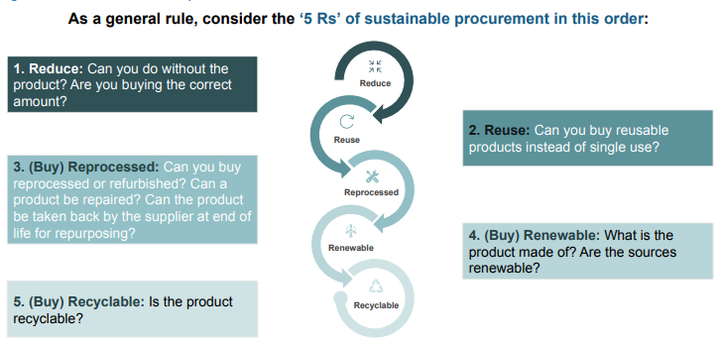

Appendix B – Circular Economy Principles

Infographic of circular economy principles of each stage of products lifecycle: 
1. Design - design for disassembly, minimal use of materials, design for durability, cradle to cradle
2. Manufacture - recyclable materials, disassembly technologies, bio-degradable materials
3. Supply and service - reduced packaging, collaborative consumption, incentivised return, hiring and leasing
4. Remanufacturing, refurbishment and reuse - material recycling, external re-use, re-use and re-deploy, closed loop recycling. 

Appendix C – Acceptable Waste Receptacles

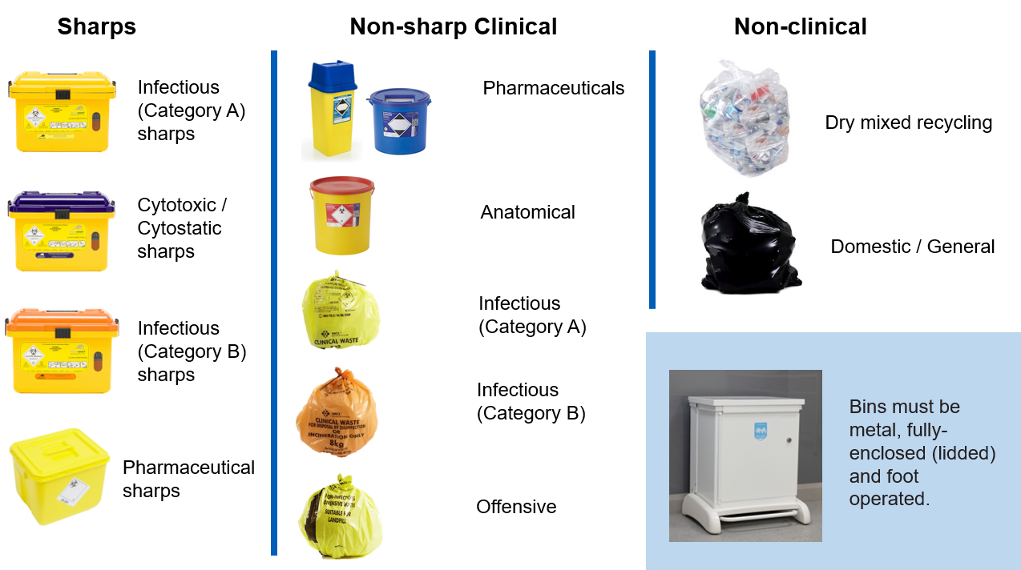

Appendix D – BioTrack Labels

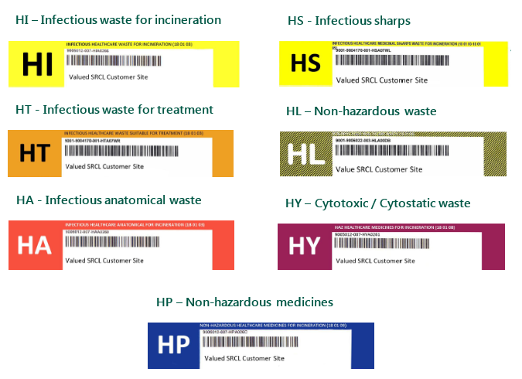

Appendix E – Relationships between waste types

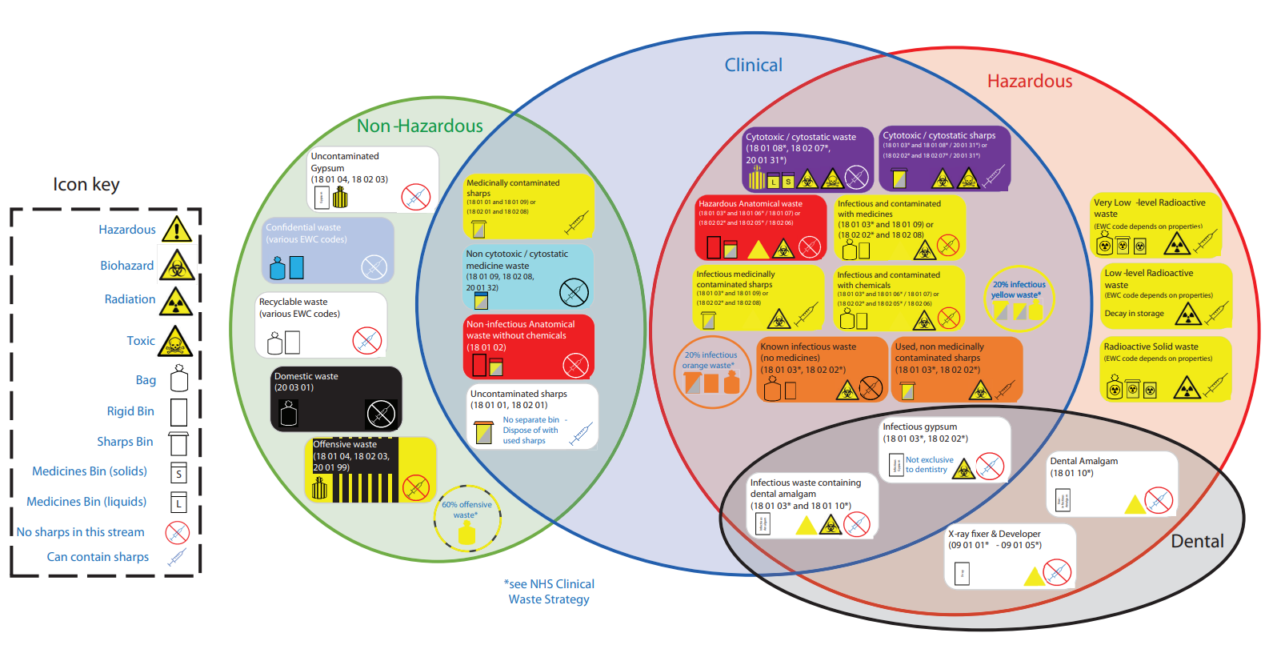

Appendix F – Waste segregation and classification

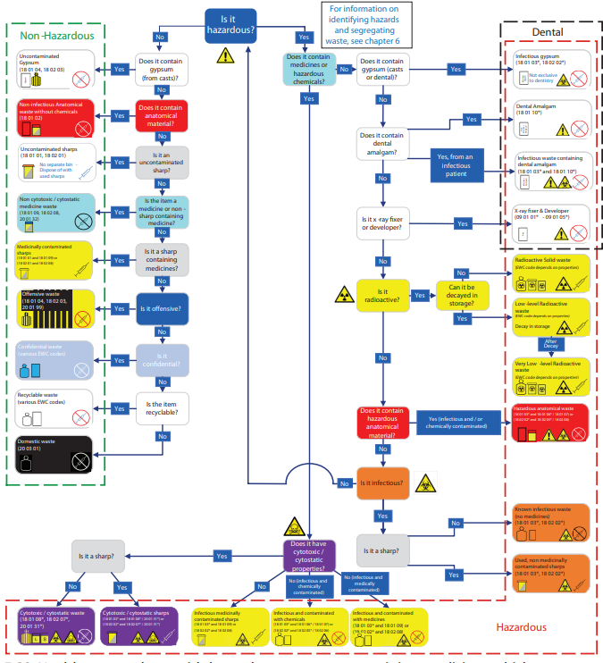

Appendix G – Waste Transfer Note

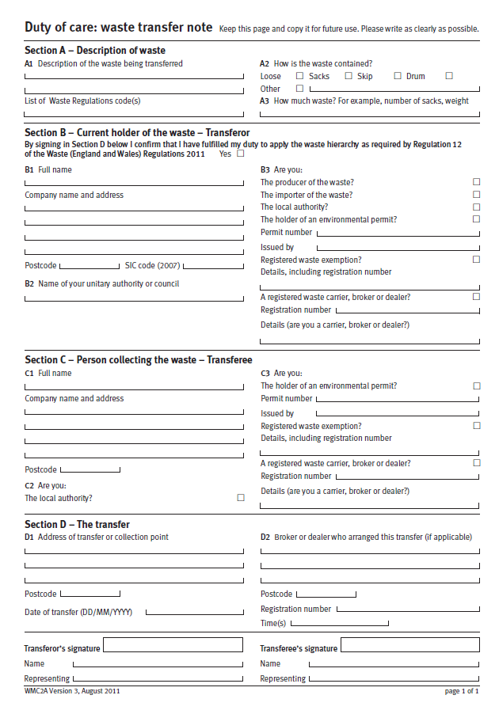

Appendix H – Hazardous Waste Consignment Note

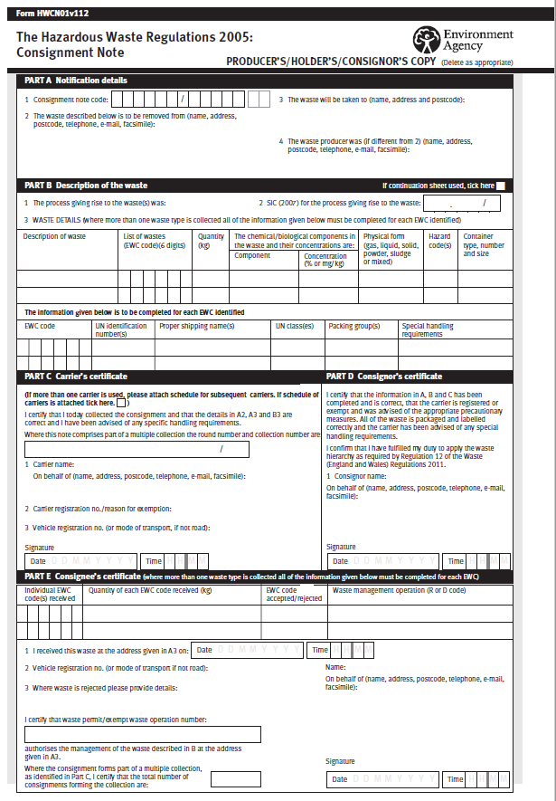

Appendix I – Duty of Care Checklist

