Appendix 1:

North Bristol NHS Trust Green Plan Annual Report

Summary of Progress

Clinical and corporate teams across the Trust made a tremendous effort throughout 2023-24 to reduce waste and carbon within their areas. The Trust was able to make significant progress across the key Green Plan areas (supply chain, travel, energy, waste, medicines) despite limited resource and funding.

1. **Key achievements the Trust made in 2023-24 and so far in 2024-25:**

* Successfully obtained funding to improve the Head Injury Therapy Unit’s Eco Therapy Garden and deliver green social prescribing programmes for patients to address health inequalities associated with access to nature.
* Our Emergency Department achieved a Bronze Award in the GreenED framework.
* Our Anaesthetics department received brilliant feedback from the Royal College of Anaesthetists through the Anaesthesia Clinical Services Accreditation and have effectively decommissioned Desflurane across threatres and have significantly reduced their use of Isoflurane.
* We developed and introduced the Sustainability Impact Assessment which has been shared widely across the UK and has been adopted into the ICB’s gateway process.
* We were successful in receiving £11.7 million of Public Sector Decarbonisation Funding and £438k of the Low Carbon Skills Fund to decarbonise our heating and deliver energy efficiency improvement projects.
* We have partnered with WECA to trial an electric cargo bike in our facilities department as part of their Urban Freight Trial.
* Our loan bike scheme has been popular with 55 bikes loaned to staff.
* We delivered a world first Green Operating Day across five of our Neurosurgery theatres which has been shortlisted for a HSJ Award and has spiked the interest of surgeons and academics across the country.
* Our pharmacy team has begun the return and reuse of medicines from wards as well as looking into other opportunities to recycle medicines waste.
* Our Infection Control team has embedded sustainability within their audit process and have trialled sustainable products that reduce waste and are safer for our staff and patients.
* In Radiology, a consultant has reduced energy consumption of their PACS machines by 58% through working with the manufacturer.
* The Sustainable Pathology Group have developed their own sustainability strategy and have successfully persuaded the NHS to fund their laboratories in gaining a widely recognised sustainability accreditation.
* Procurement have assessed the carbon reduction plans and sustainability strategies of our top 100 suppliers and have provided the opportunity to collaborate to achieve net zero carbon together.
* Patient First has embedded sustainability within their Patient First Delivery training and A3 problem solving.

1. **Our Trust’s Carbon Footprint**

The Trust’s carbon footprint is calculated using multiple data sources from procurement, finance, transport, waste contractors, estates, pharmacy, pay roll, BOC, the travel to work survey, Clarity Business Services and business intelligence. To this end, the carbon footprint is dependent on the accuracy, availability and granularity of this data. Timely data collection and cooperation from responsible departments to improve the data provided is therefore key to accurately calculating the carbon footprint. The raw data is available upon request.

Figure 1 displays the Trust’s carbon footprint for each financial year from 2019/20 to 2023/24 split into scope 1, 2 and 3 emissions. Scope 1 is what we directly emit through our gas and oil consumption for heating and our generators, our fleet vehicles and administration of anaesthetics. Scope 2 is what we indirectly emit through the electricity we purchase and scope 3 is what we indirectly emit through the supply chain of the products and services we buy, staff and patient travel and the treatment of our waste.

In 2023/24 the Trust emitted 32,480 tonnes CO2e more than the previous year due to increased spend on medical equipment, medicines, chemicals and reagents, diagnostic imaging and radiotherapy equipment, building and engineering services and office equipment. Carbon reductions were made through decarbonisation of our energy, decommissioning high carbon anaesthetics and reducing waste being collected for high carbon treatment.

The red section in the bar chart alludes to the carbon footprint the Trust would have if there were no sustainability improvement and carbon reduction projects completed in 2023/24. This amounts to 1.4 million kg of CO2e which highlights the work done by key departments to identify and address carbon and waste hotspots in their services. Many projects have not yet calculated carbon savings and so the true figure for carbon reduced in the last financial year is expected to be larger. We are also aware that we have not captured all sustainability projects delivered across the Trust and require support from Finance and Patient First to help us do this.

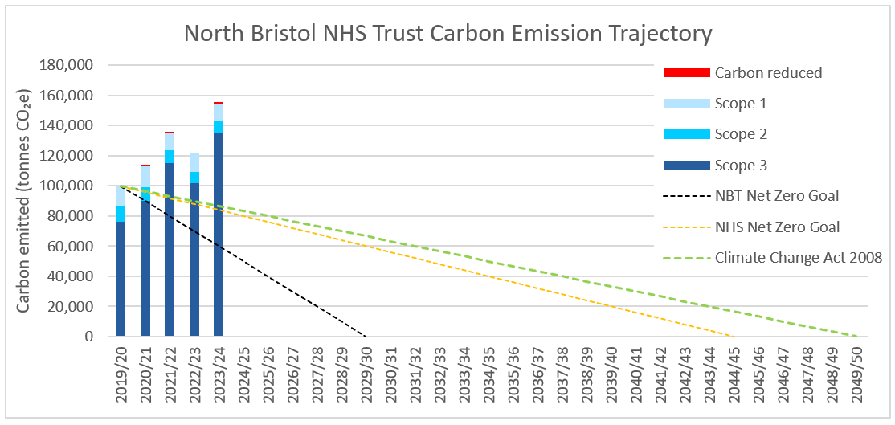

Figure 1 North Bristol NHS Trust's total carbon footprint from every financial year from 2019/20 to 2023/24 split into scope emissions and benchmarked against the Trusts net zero carbon goal, the wider NHS net zero carbon goal and the UK governments net zero carbon goal. The footprint is compared with the amount of carbon the Trust has reduced, as far as it is aware and has been able to calculate.

Figures 2, 3 and 4 below have normalised the Trust’s carbon footprint against total patient contacts, occupied internal floor area and operating expenditure.

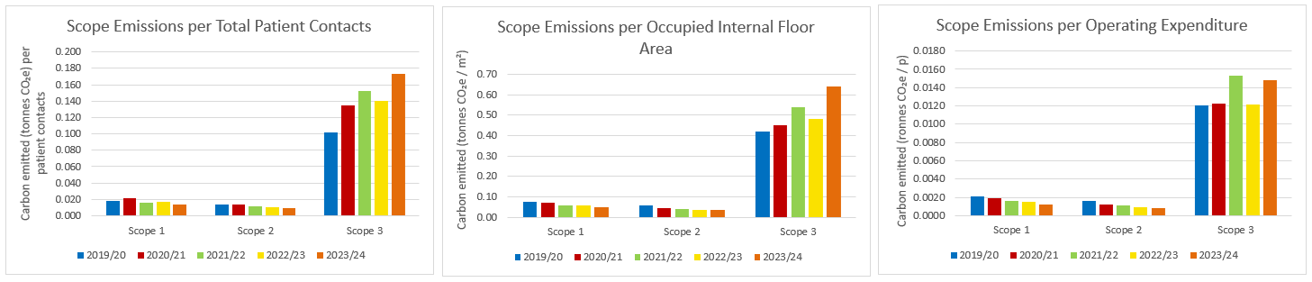

Figure 2, 3 and 4 The tonnes of carbon emitted per patient contact, meter squared of occupied floor area and pound of operating expenditure for each scope emission.

Figure 5 highlights the largest emitters that are driving the Trust’s carbon footprint. This year we have seen a reduction in carbon emitted from our buildings and energy (2,084 tonnes CO2e) and food and catering (6,305 tonnes CO2e) due to a reduction in electricity, gas and oil consumption (10,244 MWh) and a significant reduction in food and catering spend.

We have seen a significant increase in carbon emissions from medical equipment, other supply chain (comprising building and engineering services, staff and patient consulting services, staff and patient clothing and hotel services), technology and stationery, medicines and chemicals in 2023/24. This increase in carbon emissions is directly linked to an increase in spend due to an increase in activity and projects within these areas.

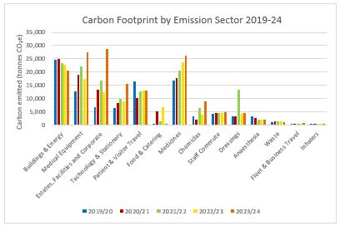

Figure 5 The carbon emitted per activity and/or category for each financial year from 2019/20 to 2023/24.

Figure 6 shows the greatest carbon emitter is ‘other supply chain’ which is comprised of spend associated with our estates, facilities and corporate departments. Medical equipment and medicines are the second and third largest carbon emitters within the Trust followed by buildings and energy and technology and stationery.

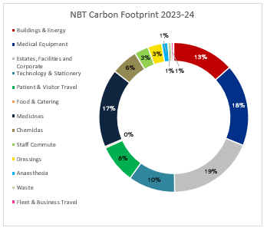

Figure 6 The percentage of carbon each key area contributes to the overall Trust carbon footprint.

As in previous years our supply chain and procurement contributes the most to our overall footprint (Figure 7). Travel and transport has decreased its contribution to the carbon footprint from the previous year by 11% however, the amount anaesthesia and waste contribute to our carbon footprint remains the same.

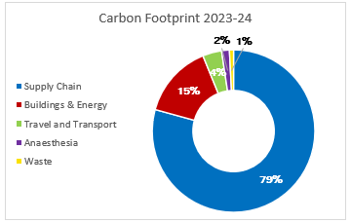

Figure 7 The percentage of carbon each key emission sector contributes to the overall Trust carbon footprint.

2.1 Supply Chain and Procurement

In 2023/24 there was a 34,618 tonnes CO2e increase from the previous year in emissions related to our supply chain and procurement activity (Figure 8). This was mainly driven by increased spend on medical and surgical equipment, technology and stationery, chemicals and reagents, building and engineering and pharmaceuticals. The bulk of the supply chain carbon footprint comes from pharmaceuticals, medical and surgical equipment, buildings and engineering services and technology and stationery (Figure 9).

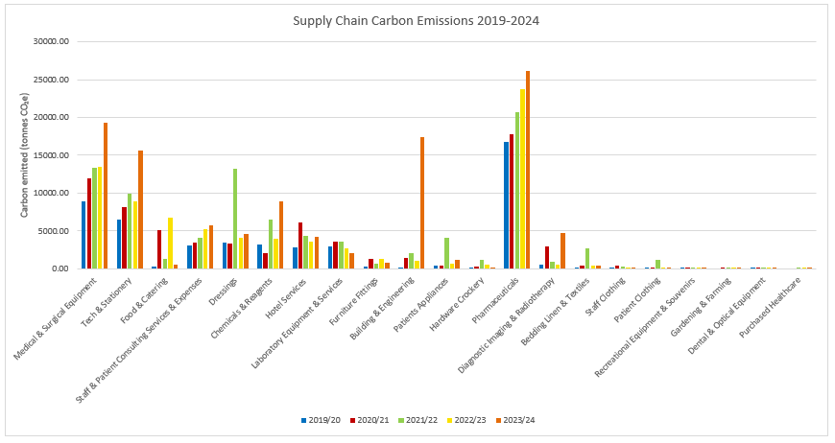

Figure 8 Carbon emitted per level 1 e class category.

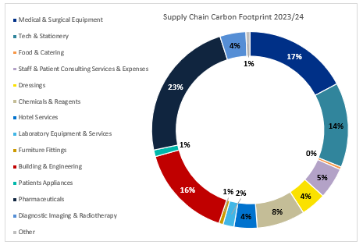

Figure 9 The percentage of carbon each level 1 e class category contributes to supply chain and procurement’s carbon footprint.

* 1. Buildings and Energy

In 2023/24, the Trust reduced carbon emitted through its electricity, gas and oil consumption by 2,068 tonnes CO2e through the decommissioning of gas boilers on site and delivery of energy efficiency and renewable energy projects such as LED lighting, solar panels, double glazing and insulation (Figure 10). The Trust consumed slightly more water in 2023/24 than the previous year which led to a 60 tonne CO2e increase (Figure 11).

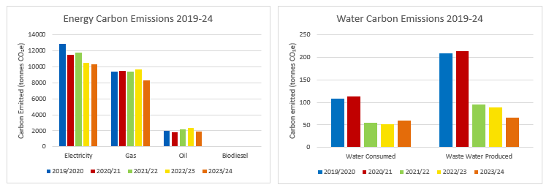

Figure 10 and 11 Carbon emitted through the Trust’s electricity, gas, oil, biodiesel and water consumption as well as waste water produced for each financial year from 2019/20 to 2023/24.

* 1. Travel and Transport

The overall carbon emissions associated with travel and transport activity increased by 40 tonnes CO2e compared to the previous year (Figure 12). This increase was driven by an increase in miles travelled through staff commute, trust fleet and business travel via staff using their own vehicles and travelling via air (Figure 13, 15).

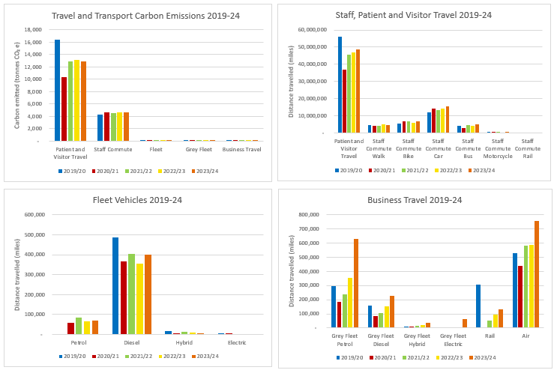

Figure 12, 13, 14 and 15 (top left, top right, bottom left, bottom right) The carbon emitted from each type of travel and the distance travelled by staff, patients and visitors to get to site and for business for each financial year from 2019/20 to 2023/24.

* 1. Medicines

Medicines, including anaesthestics and inhalers, accounted for 18% of the Trust’s carbon footprint in 2023/24 (Figure 6). The total carbon footprint of medicines purchased by the Trust increased by 2,494 tonnes CO2e in 2023/24 due to the increase in spend on medicines and increase in piped Entonox (Figure 16). Entonox use across the Trust is still significantly high particularly in our Central Delivery Suite (CDS) and Maternity Services (Figure 16). Anaesthetists took effective action in 2023/24 to decommission the highest carbon volatile agents used in theatres (Figure 17) and are taking action to identify sources of medical gas waste within CDS and Maternity.

Despite the highest carbon inhalers (pDMI) being prescribed at the highest volume, the Trust has increased the number of lower carbon inhalers it prescribes to patients (DPI, Figure 18). The Respiratory department are currently undertaking a project to address the barriers to prescribing lower carbon inhalers, making it easier for staff to identify and prescribe lower carbon options.

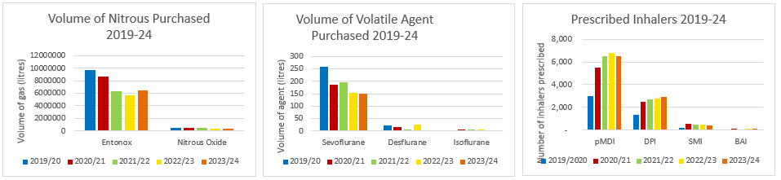

Figure 16, 17 and 18 The volume of anaesthesia (Nitrous Oxide, Entonox, Sevoflurane, Desflurane and Isoflurane) purchased by the Trust and the number of inhalers prescribed to patients each financial year.

* 1. Waste

The carbon footprint of the waste collected from the Trust in 2023/24 reduced by 213 tonnes CO2e compared to the previous year due to 257 tonnes less waste being sent for high temperature incineration and a 135 tonne reduction in waste being sent for alternative treatment; the two most carbon intensive waste treatment processes (Figure 19 and 20). This apparent reduction may be explained by the return of offensive waste classification in 2023/24 following a successful waste audit whereby all clinical waste no longer had to be classified for high temperature incineration, as was the case in 2022/23. It can also be explained by improved segregation of clinical waste as non-infectious by staff which is reflected in the progress made towards NHS England’s clinical waste segregation target (Figure 21). The Trust is still a long way off the 20:20:60 target with regards to high temperature incinerated waste and still has a lot of progress to make towards NHS England’s 50% reduction in waste target (Figure 19 and 21). We hope to achieve these targets through the new waste contracts and improved training and engagement of staff.

The Trust’s recycling rate fell from to 27% to 24% in 2023/24 although we reused 4 tonnes more waste destined for disposal, saving the Trust £109,284.59 in one year.

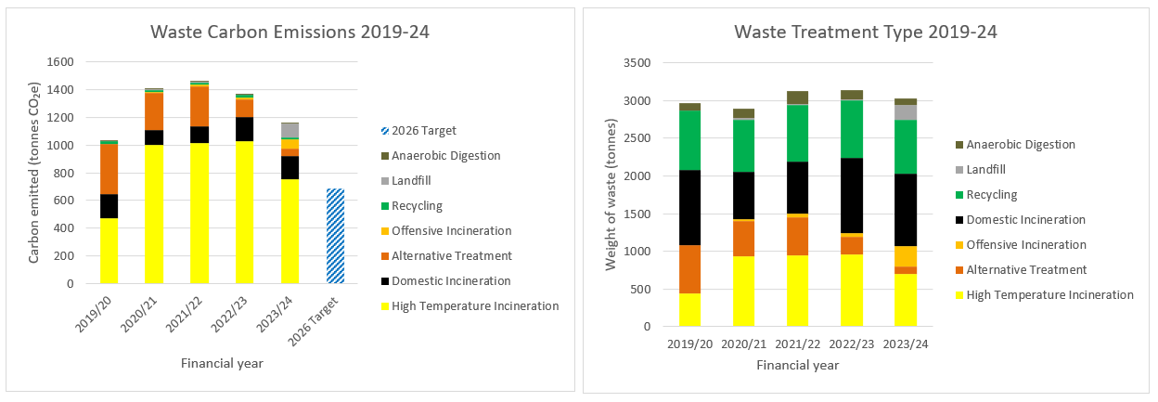

Figure 19 and 20 Weight of waste sent for different types of waste treatment and weight of waste categorized as different types of waste for each financial year.

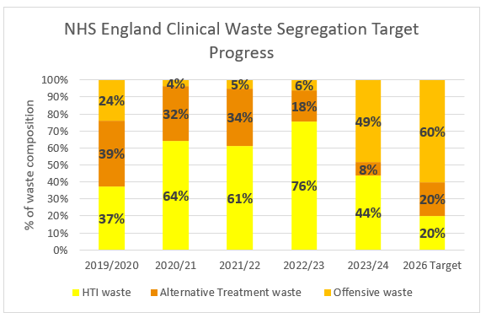

Figure 21The percentage of clinical waste classified as high temperature incinerated waste, alternative treatment waste and offensive waste for each financial year benchmarked against NHS England’s 20:20:60 clinical waste segregation target outlined in the Clinical Waste Strategy.