**Patient and Carer Experience Annual Report 2023/2024**

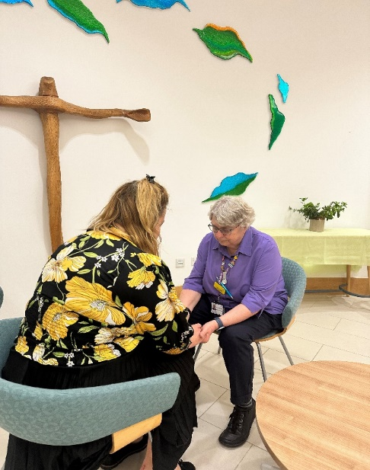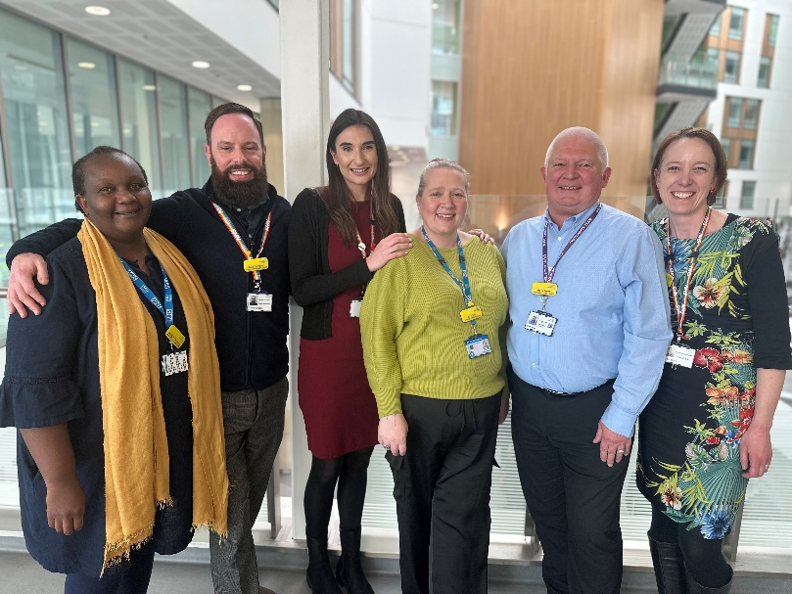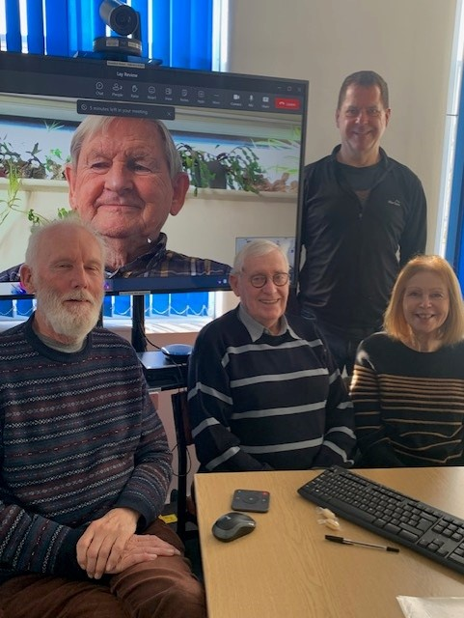

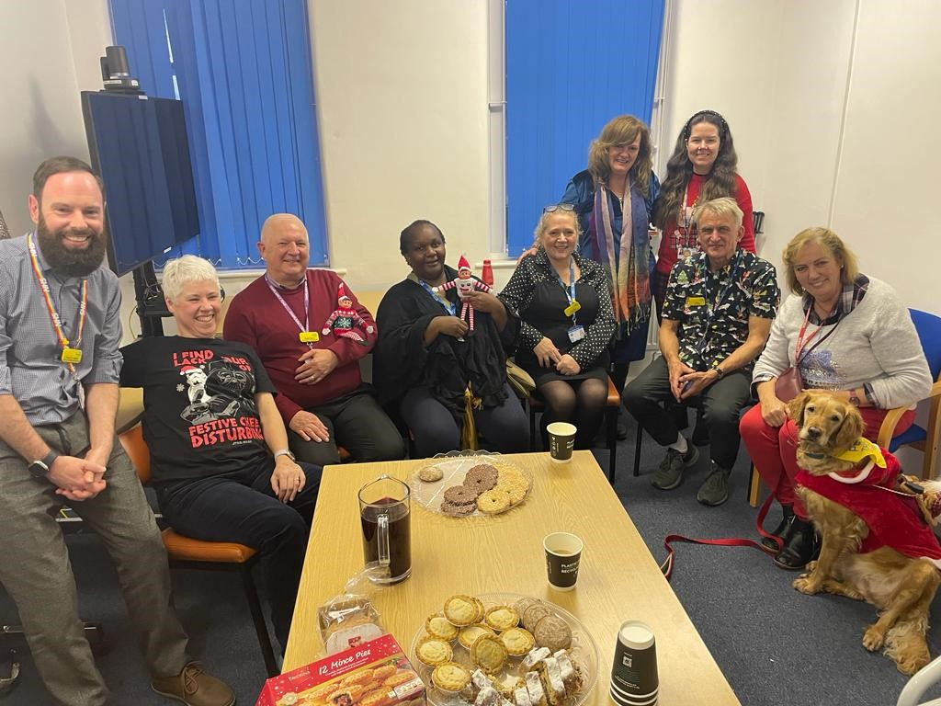

**Contents**

1. **Introduction** 1

2. **Listening to what patients tell us** 1

2.1 Friends and Family Test (FFT) 2

2.2 Local Surveys 3

2.3 Patient Conversations 3

2.4 National Survey Programme 4

2.5 Patient and Carer Partners 5

3. **Working together to support and value the individual and promote inclusion**. 6

3.1 Patient Access and Inclusion 6

3.2 Working with community partners 6

3.3 SPaRC 7

3.4 Fresh Arts 9

3.5 Volunteer Services 10

4. **Being responsive and striving for better**. 11

4.1 Complaints 11

4.2 Patient Advice and Liaison Service 15

4.3 Compliments 18

5. **Putting the spotlight on patient and carer experience**. 18

5.1 Patient stories 18

5.2 Newsletter 19

6. **Looking ahead to 2024/25** 20

# Introduction

It has been an important year for Patient and Carer Experience at North Bristol NHS Trust (NBT). In August 2023 we launched our Patient and Carer Experience Strategy. This builds on our Trust Strategy aim to deliver ‘Outstanding Patient Experience’.

The Patient and Carer Experience Strategy has allowed us to think ambitiously about how we can have the biggest impact on patient and carer experience.

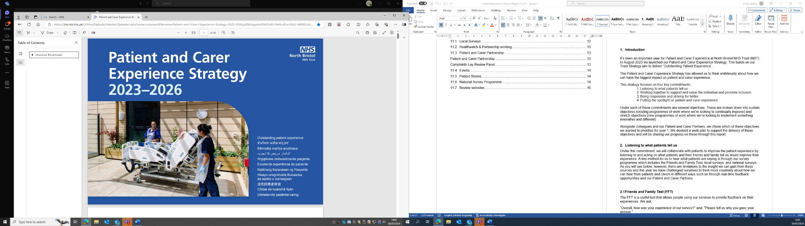

The strategy focuses on four key commitments:

1. Listening to what patients tell us
2. Working together to support and value the individual and promote inclusion
3. Being responsive and striving for better
4. Putting the spotlight on patient and carer experience

Under each of these commitments are several objectives. These are broken down into sustain objectives (existing programmes of work where we’re looking to continually improve) and stretch objectives (new programmes of work where we’re looking to implement something innovative and different).

Alongside colleagues and our Patient and Carer Partners, we chose which of these objectives we wanted to prioritise for year 1. We devised a work plan to support the delivery of these objectives and will be sharing our progress on these through this report.

# Listening to what patients tell us

Under this commitment, we will collaborate with patients to improve the patient experience by listening to and acting on what patients and their friends and family tell us would improve their experience. A key method for us to hear what patients are saying is through our survey programme which includes the Friends and Family Test, local surveys, and national surveys. As you will see below, however, there are limitations to the insight we can gain from these sources and this year we have challenged ourselves to think more creatively about how we can hear from patients and carers in different ways such as through a real-time feedback opportunity.

# Friends and Family Test (FFT)

The FFT is a useful tool that allows people using our services to provide feedback on their experiences. We ask:

“Overall, how was your experience of our service?” and, “Please tell us why you gave your answer.”

Between 1st April 2023 to 31st March 2024, a total of 103,576 responses were received. This is an increase of 31% from last year. Our Trust-wide response rate has remained at 16% and we have improved our positive rating from 91.41% in 2022/23 to 92.67% in 2023/24. This is a significant achievement against the commitment ‘listening to what patients tell us’ and our objective to improve FFT scores.

The table below shows the positive score against each care domain. The arrow indicates whether this has improved, declined, or remained in line with the previous year.

| **2024/25** | **Response rate** | **Rating (positive)** | **Trajectory** |
| --- | --- | --- | --- |
| **Trust-wide** | 16% | 92.67% |  |
| **Emergency Department** | 20% | 80.03% |  |
| **Inpatients** | 22% | 89.65% |  |
| **Outpatients** | 14% | 95.08% |  |
| **Birth** | 27% | 95.01% |  |
| **Day-case** | 21% | 96.22% |  |

This year the top positive and negative themes for FFT remain unchanged. The top two negative themes, ‘Waiting time’ and ‘Communication’ align with the top themes we have heard through PALS concerns.

Aside from our objective to improve our FFT scores, we also had an objective to ensure that the FFT data given to front-line teams was reliable and reflective of their services. Since July 2023, we have not had any data quality issues with FFT. This means that we can confidently encourage staff to log in, review feedback and comments for their area of work and be assured that this is accurate and reflective of their service. Whilst we are pleased to have made this progress, we still have much more work to do to ensure consistent use of FFT data by front-line teams so they can hear what patients are saying about their services and act on this.

# Local Surveys

The Trust continues to use local surveys to collect more targeted feedback from patients and staff. These surveys help us to understand the experience of specific patients, the impact of changes or proposed changes on patients and to understand how we can improve our services. Currently, we have 112 active surveys. This is 21 more than last year.

Due to sickness within the team, we have been unable to develop this part of our programme as much as we would have liked. Next year we hope to complete some work to audit the outcomes of these surveys to ensure that, where we are asking patients to give us feedback, we are using this.

# Patient Conversations

We know from our national inpatient survey results that only 8% of our patients say they are asked to give views on the quality of care during their stay. We wanted to improve this and offer an ‘in the moment’ opportunity to chat with our patients and hear about their experiences in their own words, reflecting on what matters most to them. With this in mind, we developed our ‘patient conversations’ framework.

This approach asks staff or volunteers to go to wards and chat with patients. They do not go with a set agenda or questions but instead will listen whilst the patient talks about their experience of being in our hospital. The volunteer will then share this feedback with the ward manager immediately, so opportunities for improvement can be implemented without delay.

We also consider overarching themes from the feedback with our other sources of patient experience data (e.g., Complaints, PALS, local surveys) and direct broader improvement work.

We launched patient conversations in October 2023, and to date, we have undertaken 17 patient conversations on wards or in departments. We have 15 staff and volunteers who have been involved, and we have spoken with over 50 patients. Whilst the feedback is predominantly good and we have used this to encourage staff, we have also made quick ‘real-time’ changes to support the patient whilst they are still with us. We have also looked at longer-term opportunities to improve patient experience. For example:

* Patients were confused about visiting rules on Percy Philips. The Trust’s website has been updated to clarify that one birth partner may stay overnight with the patient**.**
* On one of the large bays in Elgar ward, only beds on one side of the ward had TVs, and not all patients had bedside tables. The ward is exploring possible charity funding to get TVs and bedside tables for all patients.
* A patient was sent incorrect information about their operation date in a letter and then received a call asking why they had not attended the operation. This was investigated with the support manager for the relevant area and identified a training and wellbeing issue with a member of the team who was making unintentional errors in their work.
* Suggestions from patients that it would be nice to have TVs in Cotswold Ward. This is being explored by the WaCH Service User Experience Team and the Gynaecology Matron.

# National Survey Programme

The Trust continues to participate in the Care Quality Commission’s National Patient Survey programme. This provides another opportunity to listen to what patients are saying about our services. In 2023/24 we received results for the Adult Inpatient Survey 2022, the Maternity Survey 2023 and, the Urgent and Emergency Care Survey 2022.

For each survey, a workshop was held with a range of staff and patient and carer partners to review the results and agree on an action plan for areas for improvement. The results and action plans were shared with the Trust Board for each of the surveys.

For the Adult Inpatient Survey 2022, patients scored their overall experience whilst in the hospital as 8.3 out of 10. This is the same score as last year and we are proud to have maintained a good overall experience for our patients despite significant pressures on our services. Our areas for improvement include discharge, access to drinks and asking patients to give feedback during their stay.

In the Maternity Survey 2023, women and birthing people felt they were treated with respect and dignity, kindness and compassion.  Our scores in this area were top in the Southwest region and were also all above the national average, showing how caring and supportive our teams are of those in our care. Respondents to the survey said they had confidence and trust in staff during labour and birth, with our score of 9.5 above the national average of 8.7. Women and people in our care felt they were listened to by midwives during antenatal care (9.5, while the average was 9.1).  Our lowest-scoring area was around partners being able to stay as long as they wanted after birth. We are aware that this has been a frustration for people using our maternity services since the COVID-19 pandemic. We reintroduced partners being able to stay overnight on our postnatal wards in April 2023 and hope this will reassure those giving birth with us and will be reflected in next year’s survey.

In the Urgent and Emergency Care Survey, most of our patients felt listened to (8.9), had confidence and trust in the doctors and nurses who treated them (8.8) and felt they were given enough privacy (9.1). The Trust also performed better than most other trusts in meeting the communication needs of our patients (7.4) and providing them with suitable food and drink while in the department (7.9).

# Patient and Carer Partners A photo of the Patient and Carer Partners 20th Celebration event with 11 people (staff and patient partners) stood in a line in a hall with a big screen behind them with Thank you written on it and 'celebrating 20 years of Patient and Carer Partners at NBT.

In October 2023 we celebrated the 20th anniversary of the Patient and Carer Partnership. We held a celebration event where we were able to reflect on the impact of the partnership over the past 20 years and thanked all our partners for their incredible contributions.

The Partnership continues to grow from strength to strength. As reflected in our objectives for this year we wanted to focus on developing wider representation within the group and gain insights from specific conditions or demographic backgrounds so we could listen to a wider range of patients and carers. We now have 17 Patient and Carer Partners, welcoming 6 new partners over the past 12 months. Within this, we have:

* + Two partners with lived experience of cancer services.
  + A partner under 30.
  + Two partners who are members of the LGBTQ+ community.
  + A partner with lived experience of mental health.

Our partners continue to share their lived experiences of our services and use their skills and expertise to help us think about how we improve for our patients and carers. Examples of some of the activities they have been doing include:

* Participating in the Patient Led Assessments of the Care Environment (PLACE)
* Participating in interview panels for new members of staff, clinical and non-clinical
* Reviewing leaflets, posters, and webpages
* Co-designing training
* Attendance at various groups and committees (Patient Safety Committee, Patient and Carer Experience Group, Clinical Effectiveness and Audit Committee to name a few)

# Working together to support and value the individual and promote inclusion

We have committed to valuing the individual by understanding what matters most to them and delivering on this. This means supporting personalised care approaches and understanding that people’s experience goes beyond their physical treatment to include spiritual, religious, and pastoral care for example. Under this commitment, we are also seeking to hear from all our patients, particularly those from seldom-heard groups.

# Patient Access and Inclusion

In our year 1 work plan we set ourselves the objective to understand what good patient experience means to all our patients, particularly those seldom-heard voices in our local community so we can act upon this. We successfully recruited a Patient Access and Inclusion Lead into the team to support this work.

We have begun engaging with two groups, those experiencing homelessness and the Gypsy, Roma and Traveller community. Working with the Voluntary, Community and Social Enterprise (VCSE) sector and partnering with colleagues in Sirona and UHBW, we have started building trusted relationships with these groups to understand better their experience of care and treatment in our services.

# Working with community partners

We have continued to build on our well-established relationship with the Bristol Sight Loss Council (now West of England Sight Loss Council). The Sight Loss Council were awarded Team of the Year at the Rodney Powell Volunteer Awards, for the work they did collaborating with us to improve accessibility across healthcare settings and embed the Accessible Information Standard. We look forward to continuing our ongoing work together over the next year.

In February 2024 we hosted the Bristol Deaf Health Partnership for the first face-to-face meeting of the group since before COVID-19.

We have also welcomed Healthwatch on-site to run a monthly feedback stall from our hospital atrium and value the feedback they share with us. In December 2023, we commissioned Healthwatch to undertake a project for us, looking into the experiences of those waiting for surgery (specifically from areas of low deprivation, patients with learning disabilities & autism and other marginalised groups). We await the outcome of this report and actioning the findings in 2024/2025.

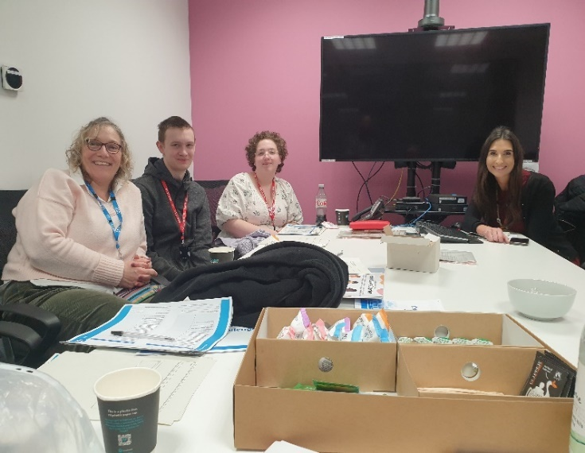

In January 2024, we welcomed five young carers to undertake the 15-step- challenge in three of our inpatient ward areas. This marks the start of our work with the Carers Support Centre and Young Carers Group to better understand their experience of accessing our services with the person they care for. We have been able to use their feedback to draw up an action plan which we will work through in the next year, asking the group to check and challenge our progress. We have also been an early supporter of the ‘Young Carers Covenant’ and were one of four organisations noted as having pledged commitment to the Covenant at the time of its launch in March 2024.

# SPaRC

Within our Patient and Carer Experience Strategy, we set ourselves an objective to continue to provide an inclusive person-centred holistic, spiritual, pastoral, and religious care (SPaRC) service.​ In July 2023, we launched a new Spiritual, Pastoral, and Religious Care (SPaRC) Strategic Plan. The strategic plan supports the delivery of the Patient and Carer Experience Strategy and has four key objective areas:

* + Develop person-centred holistic, spiritual, pastoral, and religious care.
  + Develop the Spiritual, Pastoral, and Religious Care Team.
  + Develop faith community partnership and collaboration.
  + Develop spiritual, pastoral, and religious well-being support for all NBT staff.

Despite significant staffing challenges, good progress was made against each of these objectives supporting the delivery of an inclusive, person-centred holistic, SPaRC service. Below is a summary of some of the key achievements of this service over the past 12 months.

Activity levels have increased. From April 2023 to March 2024, we carried out 2566 significant visits to 1518 adult patients. This is almost double what we achieved in the previous year. In the same period, we were able to support 272 patients who were Purple Butterfly (at end of life) and 174 who were receiving palliative care. We also supported 167 people at the End of Life. This shows awareness of the SPaRC service by patients, family, carers, staff, and faith communities has improved with more people accessing the service.

The new website was launched and improved resources for staff were uploaded on the intranet. New patient and staff information leaflets and resources covering a range of SPaRC needs have been developed.

Move to using CareFlow with new Chaplaincy Narrative Forms. This benefits patients as it promotes holistic care and is shared with other appropriate staff in real-time.



A new holistic SPaRC assessment tool was produced.

There has been an overhaul of processes, administration, funerals, and chaplaincy support following a baby loss. From April 2023 to March 2024, the team conducted 77 baby funerals including 13 communal (batch) cremations. This is up from 58 baby funerals in the previous year. In addition, chaplains were involved in supporting 18 families who made their own funeral arrangements and 5 Muslim baby deaths. Supporting parents and families, arranging, and conducting baby funerals and being adaptive to the needs of each situation takes time, skill, and compassionate care so improving the processes has been of huge benefit.

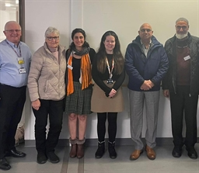

We hosted our first Faith Communities Event and established stronger community links (picture to the left).



We have provided training in recognising and responding to people’s spiritual, pastoral, and religious needs to over 120 staff in eight training sessions and SPaRC is featured in every staff induction. We have produced PowerPoint presentations to support this training, and these are all available as a staff resource on LINK.

Reflective Practice and Supervision has been introduced for Chaplains. Chaplains provide a wide range of emotional, psychological, spiritual, pastoral, and religious support to people in highly complex and distressing circumstances. High levels of sickness absences have impacted the team. In response, this year we increased the wellbeing and pastoral support offered to the team. We arranged several new reflective practice sessions enabling the chaplaincy team to reflect on areas of practice. We also put in place arrangements for chaplains to begin receiving external pastoral supervision to support their wellbeing and practice. Supervision began in April 2024.

# Fresh Arts

We were pleased to be able to welcome Fresh Arts to the Patient Experience Team in February 2024. The Fresh Arts service exists to enhance patient, visitor and staff experience of our hospitals and services through a high-quality and engaging arts programme. Fresh Arts has a standalone Strategic Plan to underpin its work. This directly supports the vision and aims of the Patient and Carer Experience Strategy, how we support and value the individual. Every day, we see and experience extraordinary moments with our patients when they reconnect with who they are through the power of the arts.

A summary of some of the key achievements over the past 12 months are noted below:

 We presented a programme of exhibitions across NBT’s sites with 16 different exhibitions shown during the year. Exhibitions related to themes like LGBTQI+ History Month, Parkinson’s Awareness Month, Greener NHS, Black History Month, and Mental Health Awareness Week. In response to feedback from patients and staff we created new exhibition spaces in Women’s &Children’s Division and Pathology enabling us to tour exhibitions across the site so more people can enjoy the arts. Our partnership with the University of Bristol research project Sensing Spaces of Healthcare, enabled us to create our first exhibition in W&CH and they gifted several artworks to us to add to our permanent art collection.

A group of brilliant, brave and inspiring patients (being cared for by the Drug & Alcohol Care Recovery Team) joined us for an Arts on Referral programme and unveiled a triptych of three collaborative artworks they made at the entrance to Gate 8A. Talk about Patient First!

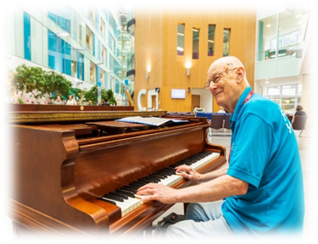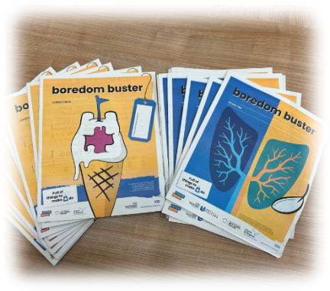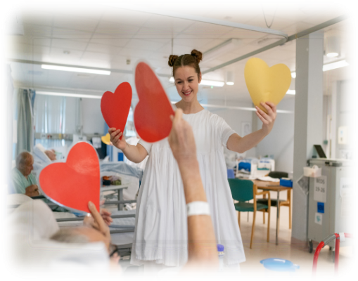

On Monday afternoons Dance for Dementia has taken place on the Elgar Enablement Unit. During the year, 1154 patients, visitors and staff danced, sang, wiggled, jived and crooned for 2 hours every week. That’s 74 hours of patient activity evidenced by increases in fluid intake, increased appetites, better sleep, and some very hearty laughter.

Our music programme has provided 135 hours of live music featuring 34 professional musicians across the Southmead Hospital site with a total audience of over 4200 people including over 1200 patients, 1600 staff and 1200 visitors. At Cossham we delivered 85 hours of live music featuring 8 professional musicians to a total audience of more than 500.

We handed out 6942 resources for patients on wards, in clinics and in waiting areas to help pass their time in the hospital. This included 5000 Boredom Buster magazines, 600 colouring books and pens and 1300 hand-knitted blankets, teddies, Twiddle Muffs and cannula sleeves created by an amazing army of volunteer knitters.

During the year we offered 9 opportunities for 4 different patient groups to see if engaging in creative activity could help them to better manage a long-term chronic condition. 58 patients took up the challenge and joined us on Zoom and in the Community Arts Room. Our Creative Writing Follow-On Group for patients living with cancer benefited 46 patients. Overall, we delivered 152 hours of Arts on Referral programmes with 479 patient attendances with around 70% of patients continuing their creative journey in their local communities.

We supported placements for 8 UWE Music Therapy Masters Students in EEU and Rosa Burden and offered work experience for 3 young people.

# Volunteer Services

The Volunteer Services are key to helping us deliver individualised care and to supporting staff to understand and meet the individual needs of our patients.

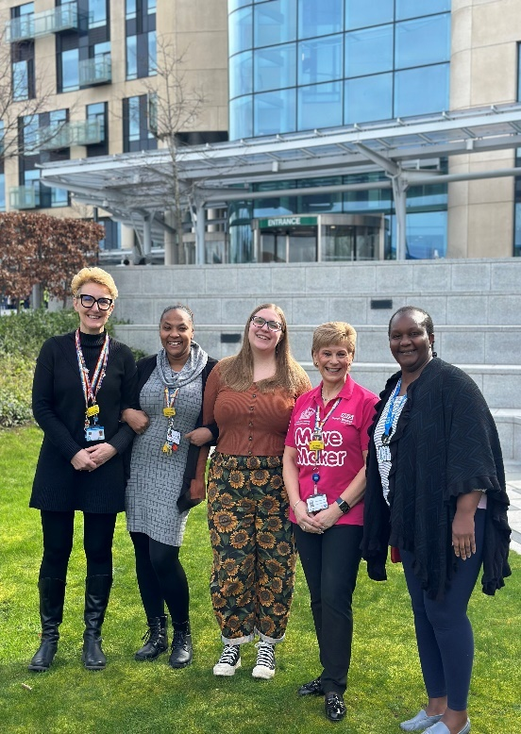

This year our amazing volunteers donated over 39,257 hours of their time. This is nearly 5,000 hours more than the previous year.

This year we have increased our active volunteer numbers by 100. We currently have 470 active volunteers across our sites, carrying out 35 different volunteering roles.

We are incredibly grateful to all our amazing volunteers for their immense commitment.

This year we developed two new roles, the Patient Feedback role and the Appointment Buddy role. The Appointment Buddy role was developed following a complaint made to the Trust about a lack of support for individuals coming in on their own to outpatient appointments. The Patient Feedback role has been developed with our volunteers who have helped evolve the role into a wider remit, with a greater impact. Developing roles in response to patient feedback and in collaboration with our volunteers has been a proud achievement.

# Being responsive and striving for better.

Under this commitment we pledged to be responsive to the feedback we receive, ensuring that we are using it to drive improvements.

# 4.1 Complaints

The NHS constitution and NHS Complaints Regulations 2009, clearly set out the rights of patients about raising complaints and expectations on how these should be managed. As a Trust, we take this duty very seriously. We want to know when someone is unhappy with the treatment or service they have received. This means we can put things right and learn from the experience of our service users.

* + 1. **Activity**

The overall number of formal complaints received by the organisation fell by 15% in 2023/24 to 560.

The graph below shows the number of complaints received by each of the divisions. The Medicine division received the most complaints followed by Anaesthesia, Surgery, Critical Care and Renal. This is consistent with the previous year where these two divisions received the most complaints.

* + 1. **Performance**

Under this commitment, we set ourselves an objective to respond to 90% of complaints within agreed timeframes. This is our Trust's internal target. Unfortunately, we did not meet this target. On average, we responded to 73% of complaints within agreed timeframes. This is 4% lower than the previous year. This is disappointing given that we had significantly fewer complaints this year; however, benchmarking against other organisations has provided helpful comparisons and we are reassured that this is still a good performance (we were 2nd for performance compared to 5 similar-sized organisations).

Despite not reaching our internal targets for complaint response times, our service is responsive at initial contact with 100% of complainants receiving an acknowledgement of their complaint within three working days.

The table below shows our performance against key performance measures.

|  |  |  |  |  |  |
| --- | --- | --- | --- | --- | --- |
| Measure | 2019/20 | 2020/21 | 2021/22 | 2022/23 | 2023/2024 |
| Complaint Acknowledged within 3 working days | - | 100% | 100% | 100% | 100% |
| Overdue complaints  (Average per month) | 8 | 0 | 5 | 5 | 5 |
| Response Time (within timescale) | 80% | 93% | 77% | 77% | 73% |
| Returned rate | - | 6% | 4% | 5% | 6% |

The team have also been working through an action plan to ensure the implementation of the new Parliamentary and Health Service Ombudsman (PHSO) standards for complaints handling. This year we have also updated the Trust’s policy for the management of complaints and concerns.

The table below shows the number of complaint cases that were investigated by the PHSO. In 2023/24, 52 cases were received by the PHSO for consideration. This means 9% of complaint cases were escalated by the complainant to the PHSO. This is a slight increase from the previous year where 7% of cases were escalated to the PHSO, however, it is consistent with years before this. Three cases were accepted for investigation by the PHSO and to date we have received 2 outcomes which were both partly upheld.

| **Year** | **Number of cases received by the PHSO** | **Number of cases accepted for investigation by the PHSO** | **Number of cases upheld or partly upheld** |
| --- | --- | --- | --- |
| **2019/20** | 61 | 3 | 0 |
| **2020/21** | 28 | 2 | 1 |
| **2021/22** | 59 | 1 | 1 |
| **2022/23** | 47 | 5 | 1 |
| **2023/24** | 52 | 3 | 2 |

**4.1.3 Themes**

The chart below shows a breakdown of complaints received by theme. Like last year the most common theme for complaints in 2023/24 was ‘Clinical Care & Treatment’.

In September a report was presented to the Trust Board which provided a deep dive into the complaint theme ‘Clinical Care and Treatment’. This deep dive showed that the main specialities receiving complaints about Clinical Care and Treatment were Emergency medicine, Obstetrics, Urology, Maternity, General medicine and Trauma and Orthopaedics

The underlying issues varied between specialities but there were some consistencies including:

• Something happening during the episode of care the patient was not expecting.

• Outcomes, potential complications, and risk of procedures not being fully explained.

• Not being able to manage a patient’s expectation of time.

• Patients feeling ignored, not listened to and not part of the decision-making process.

• Perceived delays in treatment and/or interventions.

• Attitudes of staff and expectations of professionalism (kindness and compassion) of doctors.

• Supporting with the activities of daily living i.e., eating, drinking and personal care.

• Perceived confidence in nurses and the differences experienced between day and night, substantive and agency staff.

From this, we noted key actions including accelerating the implementation of shared decision-making, to ensure there is ‘no decision about me, without me’ and continued focus on recruiting permanent colleagues and reducing turnover. This will reduce the reliance on a temporary workforce.

* + 1. **Accessibility of the Complaints Process**

We collect equality monitoring data about those accessing the complaints service through a non-mandatory form. In 2023/24 we received 40 responses. This is a response rate of 7%.

The data shows that:

• Most complainants are aged between 31-45 years.

• 38% of complainants disclosed that they had a disability.

• 82% of complainants are White-British.

We know that this is not reflective of our local population and those accessing our services. For the past year, we have welcomed Healthwatch Bristol on-site to run a monthly feedback stall from our hospital atrium. This is an alternative method of giving feedback for people who may feel uncomfortable raising concerns directly to the Trust.

We also continue to seek feedback about the accessibility of the PALS and complaints processes from service users through a questionnaire. Results show that 83% of respondents found it easy to find out how to raise a concern to PALS and 66% of respondents found it easy to find out how to raise a complaint.

As a Trust, we are committed to the principles of Ask Listen Do and strive to make it easier for people who are autistic or have a learning disability, their families and carers, to give feedback, raise concerns and complain. We have an easy-read booklet on how to give feedback and our Complaints and PALS officers have received training from our Learning Disabilities team and have all completed Oliver McGowan Training.

In the past 12 months, we have received 3 formal complaints and five PALS concerns from people who have a learning disability, their families, and carers. We also received 1 formal complaint and 3 PALS concerns from people who are autistic, their families and carers.

All of these complaints and concerns are reviewed in line with our policy and with the principles of Ask, Listen, Do and we continue to review this through annual engagement with the NHS Benchmarking Standards for people with Learning Disability and Autistic people through evaluating feedback, sharing learning and taking actions where needed.

* + 1. **Complaints Lay Review Panel**

Our coveted Complaints Lay Review Panel, regarded as a national standard setter, has continued to convene this past year, meeting once a quarter and reviewing three anonymous complaints. They look at how we handled the case, providing a score, noting areas of good practice, opportunities for improvement and whether we have closed off agreed actions. A member of the panel shares the findings with our Divisional Patient Experience Group who can take back learning to their clinical divisions.

Whilst the panel is exceptional with skilled and dedicated members, in 2024/25 we have an objective to bring some new perspectives and grow and diversify the panel further.

# Patient Advice and Liaison Service

Since its launch in 2019, PALS has continued to grow busier, demonstrating its importance as a support for patients, carers, families, and staff. The service aims to help resolve low-level concerns quickly and provide advice, support and signposting for patients, family, and carers as well as staff.

**4.2.1 Activity**

In 2023/24 1,670 PALS concerns were received, this is two more than the previous year. The chart below shows the number of PALS concerns received by divisions. NMSK received the most PALS concerns, followed by ASCR and Medicine, this is consistent with previous years.

The specialities that received the most concerns were Urology, Neurology, Trauma and Orthopaedics and Gynaecology.

**4.2.2 Performance**

We aim to acknowledge all PALS concerns within 1 working day of receipt. This year we acknowledged 100% of PALS concerns in this timeframe.

We aim to provide a response or resolution to PALS concerns in five working days; however, we acknowledge that this timeframe is guidance and that some will take less time, or more time to resolve. We, therefore, ask investigators to agree on timeframes with the person raising concerns and to respond within the agreed timeframe. In 2023/24, 75% of PALS concerns were completed within the agreed timescale. This is consistent with the previous year.

Feedback from users of PALS shows that 83% would recommend the service and 83% felt their concerns had been listened to.

**4.2.3 Themes**

The chart below shows a breakdown of PALS concerns received by theme.

The most common subject was ‘Access to Services- Clinical.’ Followed by ‘Communication’ and ‘Clinical Care and Treatment’.

This is consistent with the previous few years with cases relating to length of wait for an outpatient appointment, length of wait for surgery and communication around this.

**4.3.3 Radar**

One of our stretch objectives under this commitment, ‘being responsive and striving for better’ was to optimise our reporting and management of PALS and Complaints through our new quality governance system, Radar.

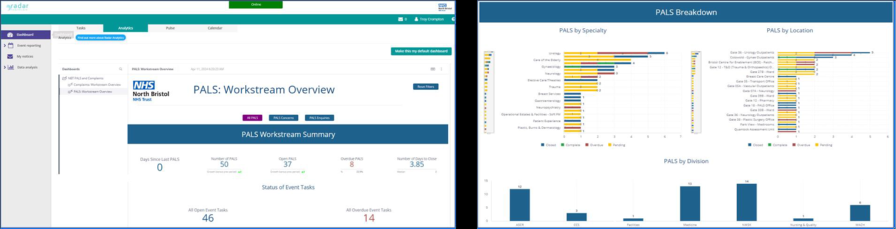

We are pleased that we have successfully transitioned from our previous quality governance system, Datix, to our new system, Radar, for the management of complaints and PALS concerns.

Over the last 18 months, we have worked to design new, streamlined workflows for complaints and PALS concerns making it much faster for our PALS and Complaints Officers to input new cases.

We also took the opportunity to review our themes for complaints and PALS concerns and have refined these to allow for more meaningful understanding of the issues raised. This includes improving the tracking of processes and themes through visualisations and dashboards tailored to user needs.

In rolling out Radar, the central team have provided 4 demo sessions, and 4 training sessions to key divisional staff. User and how-to guides have also been created. Early feedback on the system has been positive and we're excited to continue optimising its use over the next year.

# Compliments

This year we formally logged 5,781 compliments. This is a slight decrease from last year. We know that this is only a small proportion of the total compliments and ‘thank yous’ received by our staff across the Trust every day.

# Putting the spotlight on patient and carer experience.

Our fourth commitment in the Patient and Carer Strategy is to put the spotlight on patient and carer experience. We want to ensure that the patient’s voice is heard from the ward to the Board and that we have a vibrant Trust-wide vision of what a good patient experience looks like and how we can improve this.

# Patient stories

Patient stories continue to be an effective mechanism by which we can put a spotlight on an individual’s experience and hear their voice directly. One of our objectives under this commitment was to ensure that the patient’s voice is heard from the ward to the Board through patient stories. We also stated that we will not shy away from hearing stories where things have not gone well.

In June 2023, we approved the Trust’s Framework for Patient and Carer Stories. This framework, intended for staff and potential storytellers, sets out our vision for patient and carer stories.

Alongside the framework, a forward plan for 2023/24 was agreed for stories to the Board and the Patient and Carer Experience Committee. It was agreed that stories to the Board would be varied across divisions and show a more balanced view of patient experiences, including stories linked to complaints, risks, or incidents. Stories to the Patient and Carer Experience Committee would be linked to the three Trust objectives: Deliver Great Care, Healthcare for the Future and Anchor in the Community.

Against this plan, 10 stories were successfully delivered to the Board and the Patient and Carer Experience Committee. Other stories were collected during the year and used in forums such as staff training, divisional governance groups or Trust away days.

We have developed a Patient Story Hub on our intranet where stories are held and can be accessed by staff.

Thank you to all the incredible, brave storytellers who took the time to share their experiences with us this year.

# 5.2 Newsletter

Another of our objectives under this commitment was to increase the visibility of patient experience across the Trust by working with our Communications team and agreeing on a plan for sharing progress and developments within Patient Experience.

We agreed that a Patient Experience Newsletter would be a great way to showcase all our teams’ amazing work, in a creative and engaging way, that could be shared across the Trust and externally.

We launched our first newsletter in September 2023 and at the time of writing this report, we have published three editions (one each quarter). The newsletters contain a small update from each of the services within Patient Experience and a guest blog from one of our team (including our Patient and Carer Partners or volunteers).

We are incredibly proud of the newsletter which is distributed in person by our team across the Trust and published electronically on our website (along with an accessible version). Feedback about the newsletter is that it is a fantastic idea and staff have enjoyed reading it.

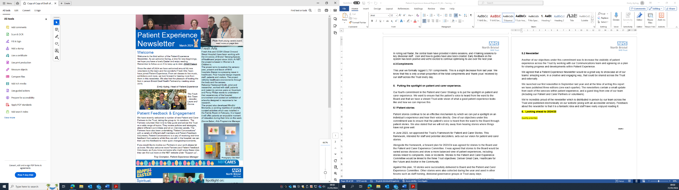 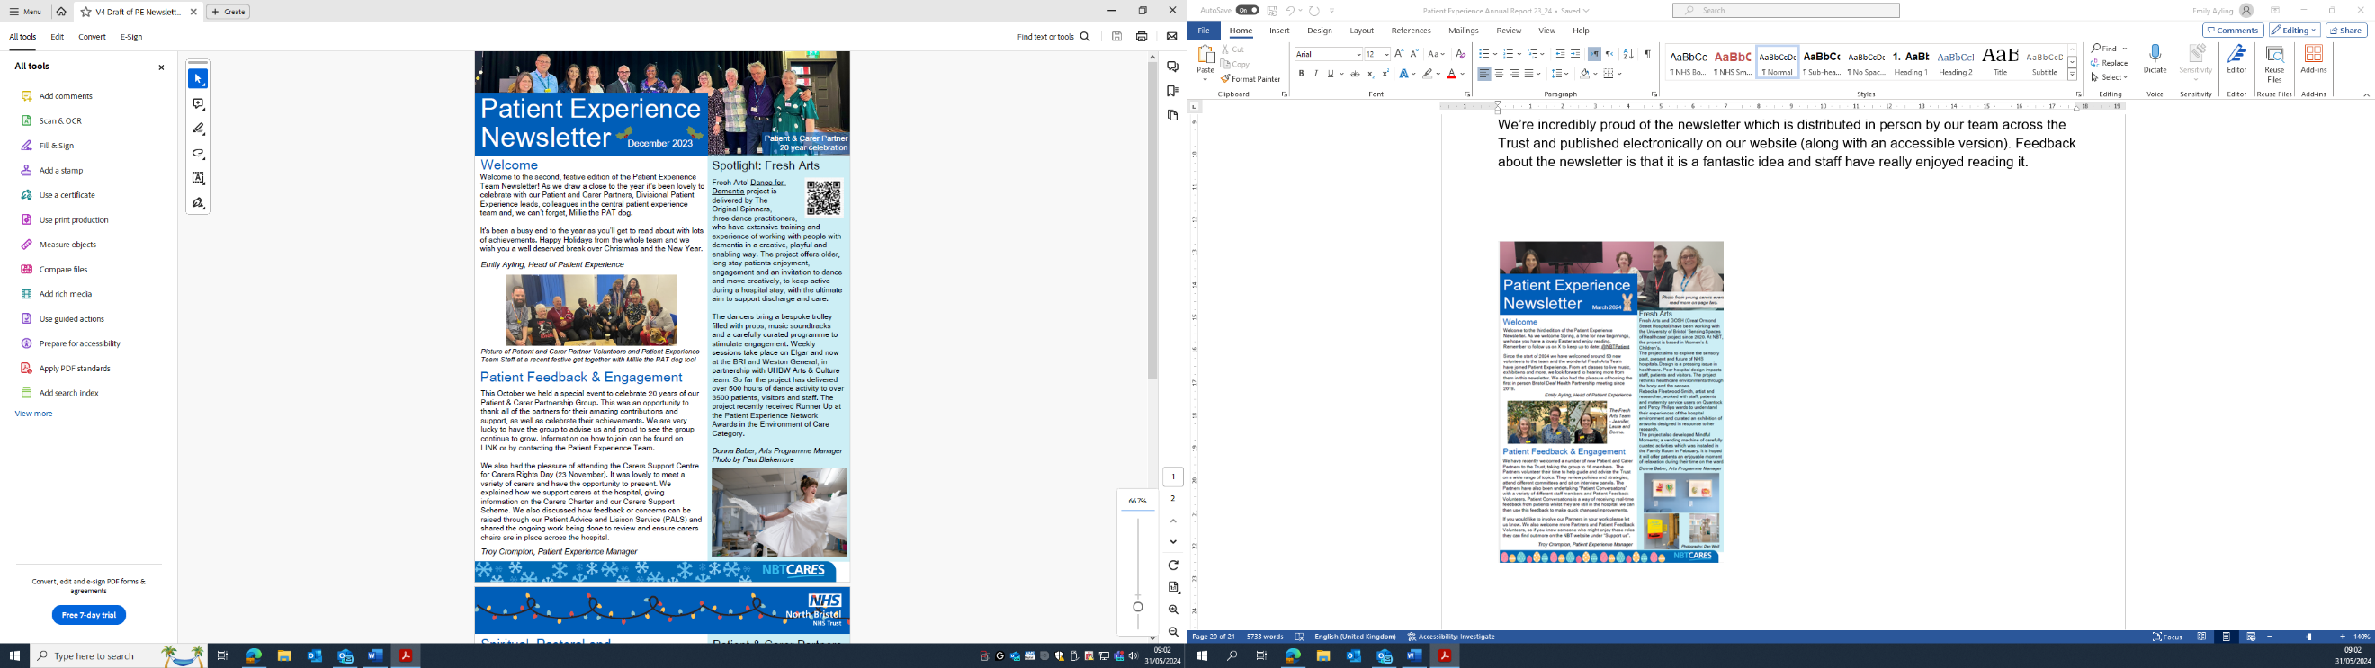

# Looking ahead to 2024/25

We have a lot to be proud of and to celebrate from the past 12 months. It has been a year of significant progress, stretching ourselves with new innovative programmes of work whilst sustaining our services to a high standard. We successfully delivered on twelve of our thirteen objectives. We look to further build on this year over the next 12 months.

Each of the individual workstreams within Patient Experience has chosen objectives from their respective strategic plans (Fresh Arts Strategic Plan, Spiritual Pastoral and Religious Care Strategic Plan, Voluntary Service Strategic Plan). For more information on these please contact the relevant service leads.

All these service-level objectives dovetail with the overarching objectives we have set ourselves for year 2 of the Patient and Carer Experience Strategy.

In conjunction with the divisional patient experience teams, central teams, patient and carer partners, the Director for Quality Governance, and the Chief Nursing Officer, we have agreed on the following year 2 objectives. Some of these have been chosen as they align with Quality Priorities, or priorities arising from other Trust Strategies such as the new Mental Health Strategy.

| **Objective Theme** | **Sustain or Stretch** | **Objective Aim** |
| --- | --- | --- |
| Listening to what patients tell us | Sustain | We will continue to share patient experiences at Board and through other governance committees, to ensure the voice of the patient is heard. |
| Listening to what patients tell us | Stretch | We will build on our existing methods to collect patient feedback ensuring these are accessible to all. We will explore the use of new technologies to support this including how we capture social listening (social media comments). |
| Listening to what patients tell us | Stretch | We will continue to develop the Integrated Performance Report so that the Board and other leaders can have oversight of the experience our patients receive. |
| Working together to support and value the individual and promote inclusion | Sustain | We will aim to increase the diversity of our volunteer teams to reflect our local community and the patients we serve, with a particular focus on Outpatient areas. |
| Working together to support and value the individual and promote inclusion | Sustain | We will meet the needs of patients with lived experience of Mental Health or Learning Disability and neurodivergent people in a person-centred way. |
| Working together to support and value the individual and promote inclusion | Sustain | The voice and the involvement of carers will be respected and integral in all we do. |
| Working together to support and value the individual and promote inclusion | Stretch | Personalised care in various services by using tools such as ‘This is Me’ developed for patients with dementia, ‘Shared Decision Making’ and “Supported Decision Making” |
| Working together to support and value the individual and promote inclusion | Stretch | We will work together with health, care, and local authority partners to reduce health inequalities, by acting on the lived experiences of patients with a protected characteristic and/or who live in communities with a high health need. |
| Being responsive and striving for better | Sustain | We will continue to sustain and grow our Complaints Lay Review Panel as part of our evaluation of the quality of our complaint investigations and responses |
| Being responsive and striving for better | Sustain | We will continue to undertake the annual Patient Led Assessments of the Care Environment (PLACE) audits and respond to areas of improvement. |
| Being responsive and striving for better | Stretch | We will involve the volunteer voice within feedback to shape future volunteer roles and patient engagement opportunities. |
| Putting the spotlight on patient and carer  experience | Sustain | We will refresh the Patient Experience portal on our website and staff intranet |
| Putting the spotlight on patient and carer  experience | Stretch | We will develop a Patient Experience e-learning module to support the ongoing need of staff for easy access to busy frontline staff. |

Updates on progress against these objectives will be shared with the Board through the monthly Integrated Performance Report. Detailed updates on specific programmes of work will be provided to the Patient and Carer Experience Group. The Patient and Carer Experience Committee will also continue to monitor progress against these objectives at regular intervals over the next 12 months.